**Department of Computer Science**

**BSCCS Final Year Project 2022-2023**

**Interim Report II**

**22CS132**

**Automated Sports Journalism**

**For Official Use Only**

|  |  |  |
| --- | --- | --- |
| Student Name | **:** | **MALHOTRA Avi** |
| Student No. | **:** | **55773896** |
| Programme Code | **:** | **BSCEGU4** |
|  |  |  |
|  |  |  |
| Supervisor | **:** | **Dr MA Chen** |
| 1st Reader | **:** | **Dr CHAN, Chung** |
| 2nd Reader | **:** | **Dr CHAN, Wing Kwong Ricky** |

*Acknowledgements*

I want to express my gratitude towards everyone who has helped me work on this final year project over the course of the academic year 2022-23. Firstly, I would like to thank my supervisor – Dr. MA Chen – for his continued support throughout the project. His valuable insights, especially during the beginning stages of the project, helped me find clarity on my project. Secondly, I would also like to express my thanks to all the professors and teaching assistants I have learnt from over the past 4 years during my undergraduate studies; the knowledge that I have gained from their classes strongarmed me with the technical skills needed to successfully complete the project. Finally, I owe a special thanks to my friends and family, who provided encouragement and moral support throughout my journey as a student.

*Student Final Year Project Declaration*

I have read the project guidelines and I understand the meaning of academic dishonesty, in particular plagiarism and collusion. I hereby declare that the work I submitted for my final year project, entitled:

**Automated Sports Journalism using NLP**

does not involve academic dishonesty. I give permission for my final year project work to be electronically scanned and if found to involve academic dishonesty, I am aware of the consequences as stated in the Project Guidelines.

|  |  |  |  |  |
| --- | --- | --- | --- | --- |
| Student Name: | MALHOTRA Avi |  | Signature: |  |
| Student ID: | 55773896 |  | Date: | March 28, 2023 |

*Abstract*

The ability to use computational techniques to mimic human speech and interaction is perhaps the cornerstone of Artificial Intelligence since Natural Language Processing is the potential communication bridge between machines and humans. This final-year project explores a practical application of Natural Language Generation, specifically in Sports Journalism. With a focus on the sport of football and the FIFA 2022 World Cup in Qatar, the culmination of this project is a product that summarizes information from web-scrapping to generate a post-match commentary on football games. The written commentary is generated using web scraping to collect raw data from live football matches. It uses fine-tuned paraphrasers and text summarizers to combine sentence fragments with information to build human-legible, cohesive content.

*Abbreviations*

NLP : Natural Language Processing

NLG : Natural Language Generation

AI : Artificial Intelligence

CNN : Convoluted Neural Networks

RNN : Recurrent Neural Networks

D2T : Data-To-Text

T2T : Text-To-Text

REG : Regular Expression Generation

POS : Parts-Of-Speech

LM : Language Model

BLEU : Bi-Lingual Evaluation Understudy

EE : Extractive Evaluation

BART : Bidirectional Auto-Regressive Transformers

GPT : Generative Pre-Trained Transformers

BERT : Bidirectional Encoder Representations from Transformers

JSONL : Java Script Object Notation Language

Table of Contents

1. Introduction 8

1.1. Motivation 8

1.2. Problem Statement 8

1.3. Scope and Objectives 8

1.4. Project Deliverables 9

2. Literature Review 10

2.1. Natural Language Processing 10

2.2. Generic Natural Language Methods 11

2.2.1 Data-To-Text Generation Pipeline 11

2.2.2. Neural Generational Systems 12

2.2.3. Knowledge-Based and Statistical Methods 13

2.3. Automated Systems for Journalism 14

3. Methodologies and Algorithms 17

3.1. Programming Frameworks 17

3.2. Assessment of Machine-Generated Text 18

3.3. Macro Planning 19

3.4. Algorithm Design 21

4. Implementation 23

4.1. Structure for Data Collection 23

4.2. Structure for NLP Model 24

4.3. Model Implementation 28

5. Results and Analysis 31

5.1. Product Testing 31

5.1.1. Linguistic Assessment (Quantitative) 31

5.1.2. Subjective Assessment (Qualitative) 35

5.2. Website Testing 41

5.3. Discussion of Articles Generated 42

5.3.1. Evaluation of Planned and Implemented Methods 42

5.3.2. Practical Constraints 44

5.4. Future Scope 45

6. Conclusion 46

7. Appendix 47

8. References 59

# Introduction

## Motivation

As a football fan since childhood and a Computer Science major, I wanted my final year project to amalgamate my two interests. I was initially drawn to predictive analysis in football, but conducting secondary research revealed that ample literature already exists on this topic. I, therefore, turned towards Natural Language Processing (hereafter NLP) and came to the epiphany of its applications in Sports Journalism.

## Problem Statement

The football market is a multi-billion-dollar industry (Fort & Fizel, 2006); subsequently, there is an everlasting growing demand for the most popular sport on the planet. Although live commentary in the sport is necessary for most viewers, many consumers also access the post-match report, summary, and analysis. However, while statistical information is available readily, there is a substantial delay in human-legible information that reaches multi-media services.

According to research by *The Bleacher Report*, one of the world’s most popular sports journalism and culture websites, reporting in football is becoming increasingly “lazy” (Kunzer, 2010). Such a problem arises primarily from a scarcity of writers, commentators, and journalists in sports journalism, where written and oral commentary is reserved mainly for an elite, revenue-generating market. This project thus aims to contribute to natural language processing by closing the information gap in the sports market. This goal shall be achieved by automating aspects of sports journalism and instantly making written sports commentary available for all football matches. Hence, this final-year project aims to reduce the time and information gap prevalent in sports journalism using automation via NLP.

## Scope and Objectives

This project's scope is restricted to the sport of football (also known as ‘soccer’ or ‘European football’). While the NLP model can be extrapolated to other sports, the use case is constrained to the most popular sport that warrants the most significant consumer demand (Dvorak et al., 2004). Moreover, given the project timeline (see *Appendices D & E* in *Section 7*), the product deliverable is specifically targeted for a post-match commentary instead of a pre-match commentary since the information gap is present for written summaries after a football match has concluded. Finally, due to the limitations of the frameworks and to model real-world sports summaries more closely, the written commentary shall be approximately 100 to 200 words. Extending this word limit is susceptible to losses in brevity, redundancy of generated text, and ineligible comprehension due to the current challenges of data-to-text generation and NLP in general.

The final year project provides an opportunity to develop tangible, real-world solutions while contributing to scientific and technical innovation in Computer Science. The objectives of this project are listed as follows: first, to collect statistical, raw data via web-scrapping from numerous internet-based sources that provide information on football matches; second, to filter and analyze the data and train an AI-driven product using NLP; third, to develop a model encompassing text summarization and text generation that can provide qualitative and quantitative (measured against pre-established criterion, see *Section 3.2*) post-match commentary of football matches.

## Project Deliverables

The final product is a user-friendly website wherein users can request commentary for football matches of the FIFA World Cup 2022. The system will consequently present the user with a short article summarizing the key events and highlights of the game.

# Literature Review

## 2.1. Natural Language Processing

Although substantial research exists on the number of real-world applications of NLP, the journalism niche is relatively nascent. However, such a constraint is not an obstacle for the proposed final year project, given that the existing literature is appropriate for this topic – both on the libraries needed to develop a model and the variety in algorithmic design.

Natural Language Generation (hereafter ‘NLG’) is a subset of NLP that defines an explicit goal towards computational linguistics and text generation. However, the very definition of NLG systems is somewhat fluid, and these systems are instead defined and distinguished based on the input types:

* **Data to Text (D2T)** – These include normalized input from structured data sources such as informative databases and pre-labeled corpora. Automated sports journalism (or robot journalism), the focus of this project, is an ideal example of such a system.
* **Text to Text (T2T)** – These include standalone sentences examined in an isolated context to express statical information in varying and creative expressions. An example of such a system is text summarization, which is also used in this project.

Gatt and Krahmer (2018) outline six critical tasks to generate an NLG system. These are summarized as follows:

1. Content Determination extracts the key information from the text. Strategic choices need to be made to distinguish helpful information from background noise. In the context of the football domain, this information is event-dependent (wherein events refer to a match goal or a red card) and includes variables such as player names, the minute of the match, the updated score-line (if needed), and the circumstance that caused the event (such as penalty kick).
2. Text Structuring determines the information's sequential order, allowing for a more planned commentary. This section may include additional information, specifically on pre-match lineups of the teams and the number of substitutions made during the ongoing game, if any.
3. Sentence Aggregation focuses on the cohesion and overall readability of the text. Nonetheless, there can be instances where the aggregation is not desired, particularly when a player scores more than 1 goal; expressing this information in a single sentence is more advantageous to avoid redundancy.
4. Lexicalization is the subsequent step that converts sentence fragments into natural language text. The pre-cursor to this step is an information vector that contains the words and phrases needed to construe a sentence.
5. Referring Expression Generation (REG) differs from lexicalization as the former prioritizes language linguistics to avoid ambiguity by establishing correct sentence-verb agreements and focusing on meaning.
6. Linguistic Realization involves the addition of words or phrases not prevalent in the original exact text or data to make the overall written commentary whole.

## 2.2. Generic Natural Language Methods

This literature review section discusses the methodologies adopted in academia to produce natural language text. Though similar in their goals, these methods vary in design and comprise different advantages and opportunity costs.

### 2.2.1 Data-To-Text Generation Pipeline

Kukich et al. (1983) and McKeown (1997) were the first researchers to develop a tangible data-to-text generation methodology to fabricate natural language text. Their strategies focused on the following tri-faceted approach: determine an output structure from a specific input (i.e., “content planning”), establish the lexical sequential ordering of every sentence (i.e., “sentence planning”), and build content with appropriate sentence linkage (i.e., “surface realization”). However, this pipeline method has become outdated by today’s industrial standards due to software advancements and new programming paradigms, as Puduppully et al. (2021) argue.

The methodologies and principles used in this sequential approach are still helpful today, by theoretical considerations at least. A conference paper first published at the European Conference for Information Retrieval (ECIR) modified Kukich’s linearized approach with a hierarchal model that prioritizes key-value pairs of words and their corresponding frequencies in professional, written commentaries (Rebuffel et al., 2020). *Figure 2.1* depicts the pictorial architecture of the encoder-encoder revised model proposed by these authors. The algorithm is trained such that it can efficiently generate a collection of words independently (using the low-level encoder “A”) and match the set with existing terminology from a given text (using the high-level encoder “B”). The model performed better than Kukich’s according to the BLEU score. Papineni et al. (2002) developed this qualitative machine-text performance metric as an alternative to expensive human evaluations (see *Section 3.2*).

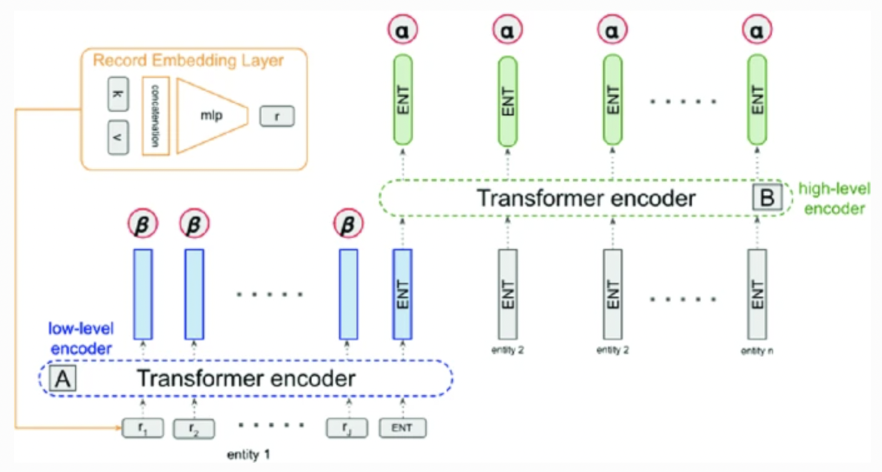

*Figure 2.1: The “encoder-decoder” architecture (Rebuffel et al., 2020).*

### 2.2.2. Neural Generational Systems

Recent advancements in neural networks in artificial intelligence have ameliorated neural generational systems and led to newfound advances in machine-generated descriptions (Mei et al., 2016; Rebret et al., 2016; Garbacea & Mei, 2016). These researchers independently concede that these algorithms produce more fluent text because they combine Recurrent Neural Networks (RNNs) with Convolutional Neural Networks (CNNs) to construct a unified end-to-end network. Nevertheless, these neural network frameworks are marginally restrictive to generating only a few (less than 4) sentences. As Wiseman et al. (2017) demonstrate, any attempts to develop a text of more than 50 words result in an incomprehensible and often redundant commentary. More importantly, the authors have also recorded instances wherein the statements produced are not factually correct or substantiated. For these reasons, this project utilizes variations of the data-to-text-generation pipeline in addition to deep learning techniques to develop the algorithm (see *Section 3.4*).

### 2.2.3. Knowledge-Based and Statistical Methods

These two systems have been specifically developed for natural language; Vincente et al. (2015) performed a comprehensive study that not only elaborated upon the various theories of knowledge-based and statistical methods but also investigated their differences. Knowledge-based methods draw strong influence from universal linguistic sources, namely dictionaries, thesauruses, and even grammar rules to develop semantically accurate information. On the other hand, statistical methods are contrasting, given their tendency to support factual information with a text corpus and build upon the probabilistic likelihood of the given words appearing in the machine-generated text.

Systemic Functional Grammar (SFG) theory is one of the most popular knowledge-based methods that ideologically view language as a network of systems and correlated sets that collectively decipher meaning (Halliday et al., 2014). A reoccurring notion of this theory is the concept of ‘stratification’, which enumerates that language should be analyzed in three levels of abstraction and functions: idea metafunction (i.e., the proposed content), interpersonal metafunction (i.e., the speech and oral communication structure), and textual metafunction (written structure and themes). Another popular theory applied in NLG systems is Rhetorical Structure Theory (RST); however, this theory aims to describe texts instead of creating new content. The theory posits a framework that recursively decomposes input text into categorical sets of words and subsequently finds relationships between these sets using a linguistic schema.

Statistical Methods, on the contrary, are heavily contingent on Language Models (LM). These models comprise a probability distribution over word sequences. A commendable model can decide whether sentences are well-formed by calculating the probability of the sentence fragments appearing altogether in a single sentence. Chen and Goodman (1996) underscore that the three most widely used LMs are: N-Gram Models, which predict the nth sequence item by using the n-1 Markov chain order and learning algorithms but are limited given their unreliability with long sentences; Stochastic Grammar Models, which assign probabilities to each grammar rule and infer derivations assuming that model definitions and parametric obstacles are overcome; Factored Language Model, which improves on traditional LMs by tokenizing each word as a vector of factors and classifying these tokens into different grammatical, Parts-Of-Speech (POS) classes.

## 2.3. Automated Systems for Journalism

Many automated systems have been modified to suit journalistic applications, but few seldom relate to the sports domain (Gunasiri, 2019). Nonetheless, two bot reporting systems are actively used: GoalGetter and GameRecaper.

GoalGetter is a system that generates Dutch oral commentaries of football matches. The data-to-speech system inputs tabulated information and produces a textual summary as output. According to Kolodny (2018) and Theune, Klabbers et al. (2000), the algorithm is a two-step iterative model wherein fixed information on the final result is retrieved. In the second pass, additional information is added to enrich the text. The critical difference between this model and the one utilized for other NLG systems is that GoalGetter does not use the pipeline architecture (see*Section 2.2.1*). *Figure 2.2* depicts the Language Generation Model (LGM) architecture of the system. The generation module contains an algorithm predominantly reliant on the syntactic tree structures containing variable information in key-value pairs. Finally, the knowledge state filters the data fragments utilized from those which are not, while the context state correlates to linguistic aspects such as grammar.

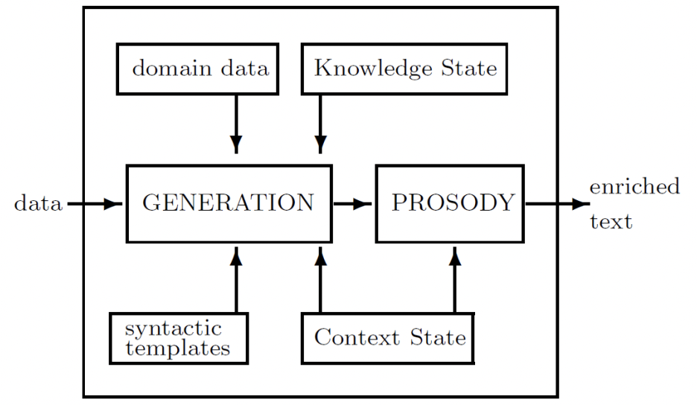

*Figure 2.2: GoalGetter Architecture (Gunasiri, 2019)*

The GameRecapper system, on the other hand, is a template-based system that generates summaries from external game sheets. It scrapes data from the web as a JavaScript Object Notation (JSON) tree, making the data collection process more organized. A similar approach was initially adopted for this project by web-scraping information from online sources (see*Section 4* and *Appendix A* in *Section 7*) but was eventually discarded given the monotony of the sentence structure across multiple commentaries (see *Section 5.3.1*). The generation module algorithm for this system includes many key aspects, each of which is defined as follows in *Figure 2.3*:

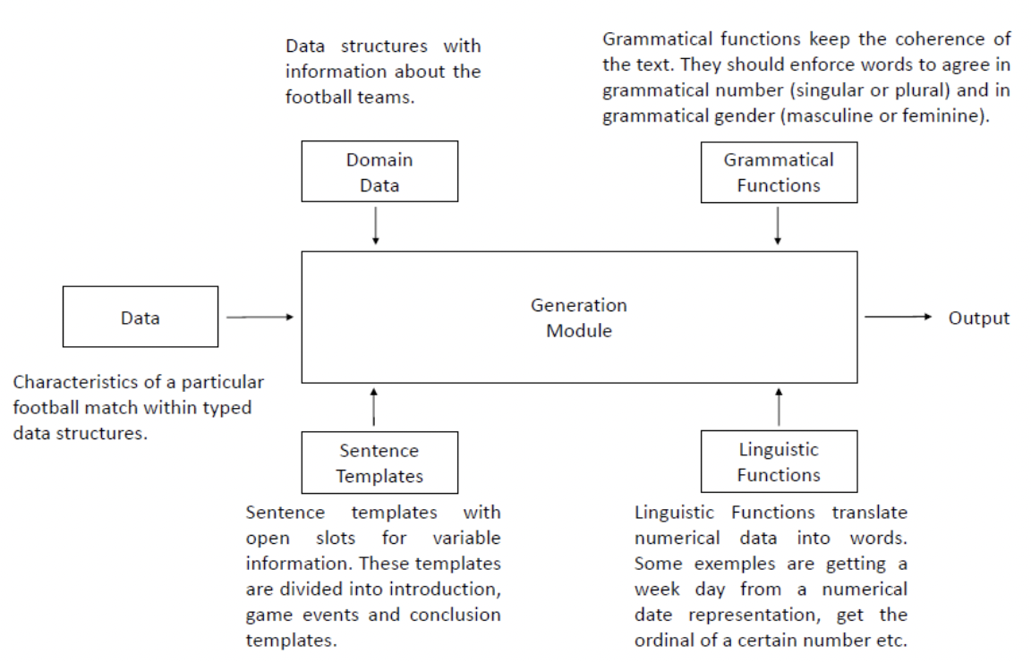

*Figure 2.3: GameRecapper Architecture (Gunasiri, 2019)*

This system achieves much higher accuracy than GoalGetter (Aries, 1998), mainly due to the assortment of sentence templates used in the framework. However, while the text generated is grammatically correct and comprehensible, there is scope for improvement given the repetition of information in the written commentaries.

# Methodologies and Algorithms

## 3.1. Programming Frameworks

Python’s versatility as a programming language and its inherent toolkits make it the ideal choice for this project. The following libraries are instrumental and included in Python version 3.9:

* The Natural Language Toolkit (NLTK) provides the foundational education needed to gain a foothold in NLP and Python.
* PyNLP helps perform calculations (such as n-grams and frequency lists) and build language models.
* Scikit-Learn encompasses the surplus of algorithms available to combat text classification (i.e., differentiation between player names, team names, numeric data, and language linguistics).
* The Selenium Library is more suited for web-scaping, which is a vital part of the project since the data collected will be parsed from official sources (such as the live commentary updates from Google Search or tweets from the FIFA World Cup Twitter account).
* Recurrent Neural Networks (RNN) is an AI network that combines deep learning techniques implemented on the dataset to predict human-legible subsequent text.
* Hugging Face is a recently developed toolkit containing a set of libraries tailor-made for text generation, given a sentence fragment. It includes numerous transformers models readily pre-trained yet available for fine-tuning as per developer needs.
* OpenAI is a library containing the company’s foremost transformer models and engines that can be accessed via an Application Programming Interface (hereafter API).
* PyTorch is the open-source machine learning framework used to build deep learning models to perform natural processing tasks such as text generation and text summarization. PyTorch contains the ‘transformers’ library, allowing access to numerous general-purpose architectures and pre-trained language models.
* SimpleNLG is a valuable tool for summarizing vast quantities of numeric and symbolic (i.e., match information) data; it provides objective, low-level text descriptions.
* Seaborn is a data visualization library used for graphically and statically testing AI-generated commentary.

## 3.2. Assessment of Machine-Generated Text

Although writers attempt to remain objective and factual in sports journalism, using descriptive words in commentary makes it intrinsically subjective. However, Steensen (2017) advocates that this is necessary to intrigue readers and avoid mundane information reporting.

Incremental testing after the product development (see *Section 5.1*) will primarily focus on factual accuracy and sentence comprehension. The latter may be evaluated using pre-existing tools to ensure the written commentary is not erroneous of grammatical errors, sentence structure, and subject-pronoun agreement.

While writing and evaluating test cases that assess the quality of the written text is challenging given the subjective and diverse nature of assessment, it is possible to test and compare the performance of the AI-written text. Bilingual Evaluation Understudy (hereafter referred to as ‘BLEU’) Scores are one of the most popular metrics in NLP (Dosh, 2021); it works based on matching the closeness between a machine-generated (predicted) text and a human-generated (targeted) text. Even though the scores range from 0 to 1, BLEU scores are often capped at 0.7 to avoid overfitting the NLP model, as supported by the findings presented by Puduppully & Lapata (2021) since a score between 0.7 – 1 is incredibly rare realistically: even two human-written commentaries are highly unlikely to produce a perfect match that is a carbon copy, almost word-for-word.

The most predominant advantage of using BLEU is that these can be tested against multiple target sentences, i.e., the natural language text can be evaluated against different human commentaries, irrespective of their medium (oral or written). Moreover, the BLEU scoring methodology corresponds to how a human would consider the exact text, allowing for a more ‘practical’ summary analysis. Lastly, BLEU scores are language-independent and can be easily applied to NLP-based models in Python.

Despite their widespread use, BLEU scores are often criticized for their weaknesses. Post (2018) advocates for “clarity in reporting BLEU scores”, while Reiter (2018) questions the very validity of these scores. Both authors proclaim that the scoring method does not consider the meaning of words: for example, the words ‘soccer’ and ‘football’ would be regarded as incorrect even though they are both synonyms. Furthermore, the understudy searches for only exact matches, diminishing its accuracy when different tenses of the word (such as ‘score’ vs. ‘scored’) or infinitive forms (‘win’ vs. ‘winning’) are examined. Given these limitations, even though BLEU scoring was considered for quantitative testing, as mentioned in the interim reports, its structural regulations deem it ineffective at comparing long sentences generated by the NLP model. Thus, transformers were used to evaluate sentences semantically (see *Section 5.1.1*).

A qualitative assessment for this project is equally as insightful as it can anchor the numeric valuations posited by quantitative, machine-based scoring. User-end review is essential, given that the end product is specifically designed for a human audience. More importantly, given the harsh critiques of Reiter & Belz (2009) on the unreliability of most quantitively numeric metrics, the NLP model testing can only benefit from human feedback. Hence, a set of Extractive Evaluations (EE) were used in addition to the semantic similarity grading metric for this project. EEs contain a subset of 3 metrics: Content Selection, Relation Generation, and Content Ordering. These performance metrics assess how well sentence fragments relate to others, emphasizing ordering word clusters, overall readability, and understanding. This is a subjective evaluation performed by a range of target audiences with varying football knowledge levels. (see *Section 5.1.2*).

## 3.3. Macro Planning

An overarching view of the entire system is depicted pictorially in *Figure 3.1*. The use case diagram describes the interplay between different system stakeholders and offers insight into the system's architecture objectively. This diagram is used as a roadmap to generate the following sequence diagram that enumerates the step-by-step process and the class diagram that uses design principles and methodologies to write efficient, modular code in tandem with object-oriented programming paradigms (see *Section 4*).

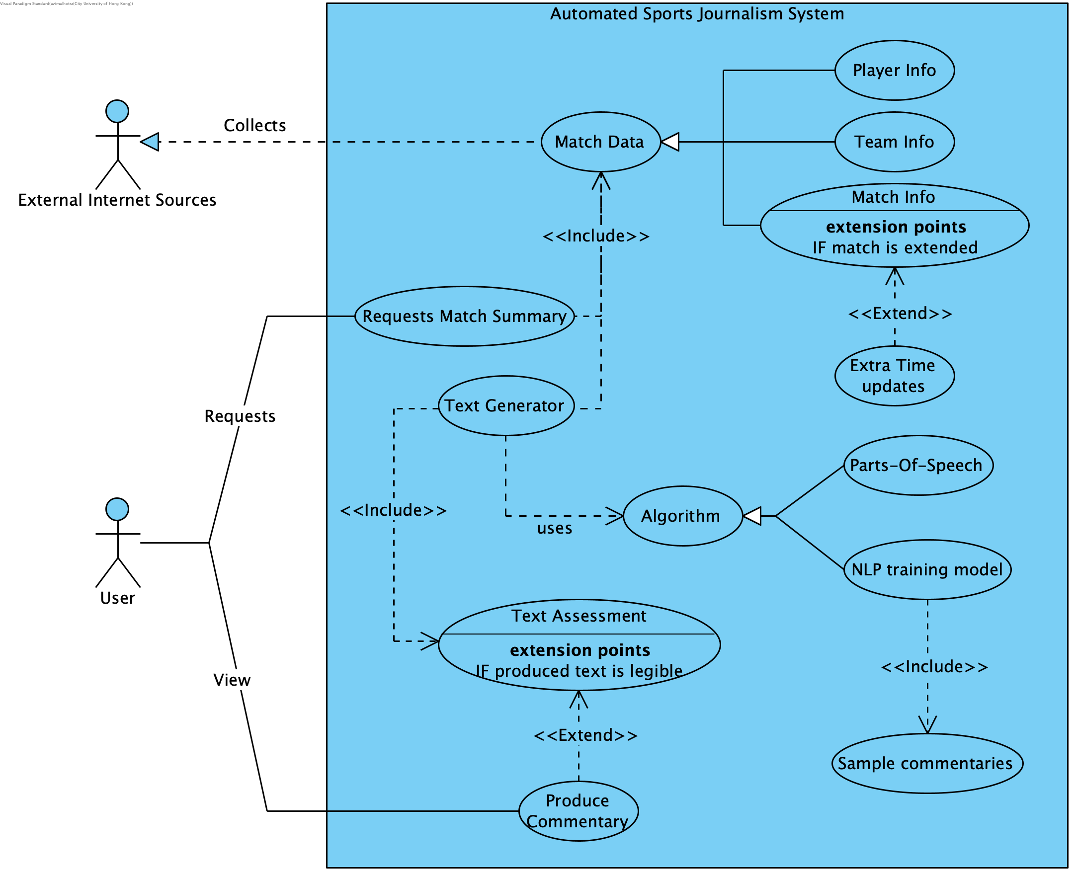

*Figure 3.1: Use Case diagram*

The template-based system introduced in *Section 2.3* is employed to plan a macro-level schematic for the modular collection and organization of the D2T model. This data shall be collected using web-scraping and containerized in JSON files with the following structure:

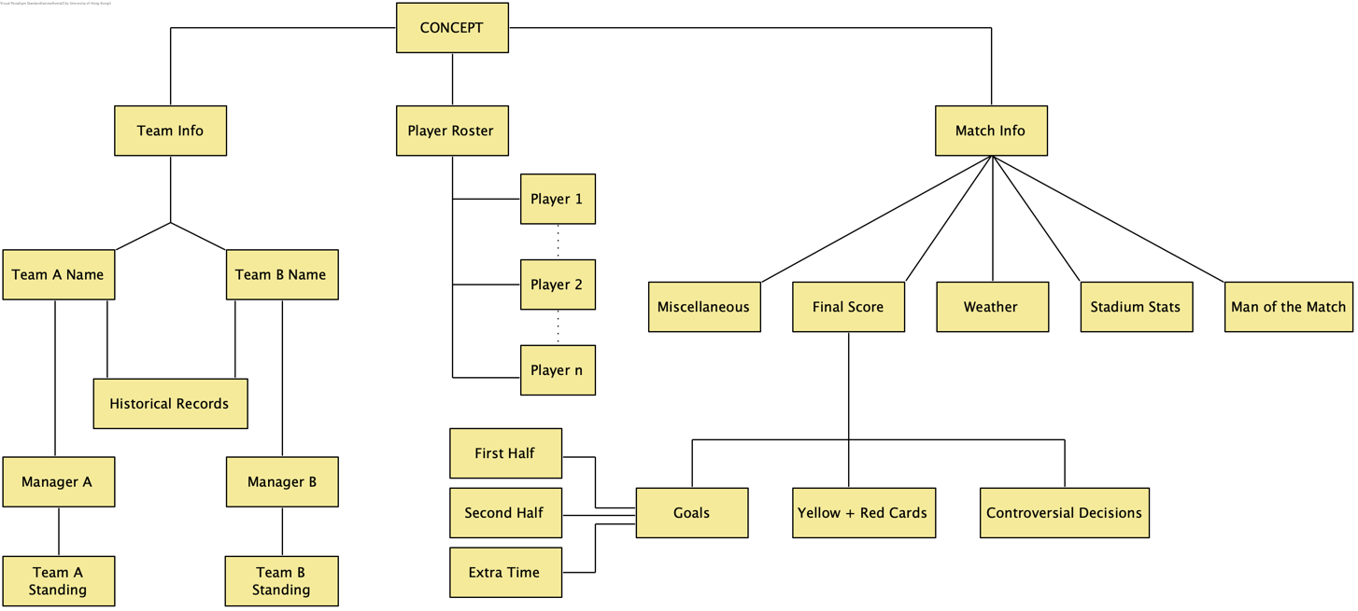

*Figure 3.2: Data Collection Schematic*

The above background information is quintessential to writing the written commentary given that it forms the very basis of the input that shall be used to not only train the NLG model framework but also collect data in real-time upon user request.

## 3.4. Algorithm Design

As depicted in *Figure 3.3*, the framework for this model fundamentally comprises two parts: sentence representation and text generation.

Sentence representation uses deep learning techniques to build a model from an idealistic sample of news articles (see *Appendix B* in*Section 7* for sample written commentaries). To generate legible natural language text, the goal is first to learn from sentences with similar corpora. Each sentence is expressed as a vector and aggregated into clusters per inter-vector similarities. The baseline clustering system uses an encoder-decoder style RNN (see *Figure 2.1* in *Section 2.2.1*). Sentences that are parallel in expression and meaning are then depicted in a cluster. Finally, vector quantization is performed using k-means clustering. Doing so allows merging any duplicate sentence vectors such that every cluster represents a unique bag of words without any comprises on the quality and overall meaning of the sentence fragment.

Text generation consists of narrative context planning and surface realization. The former fills in the information for the machine-generated text but only after planning the order of sentence clusters for the final written commentary. The latter, on the contrary, is subsequently responsible for building cohesive sentences. The D2T model parses extracted input data as a series of words from a web-scrapped source stored as a JSON object (see *Appendix A* in *Section 7*) to generate an output sequence as a sentence from a sentence set of concatenated parts of speech.

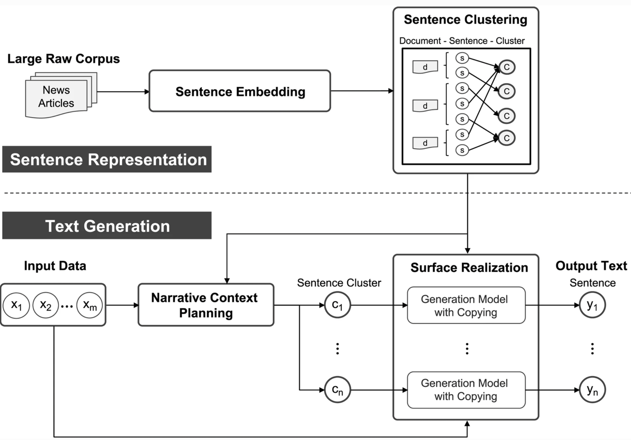

*Figure 3.3: Model Framework (Jang, Noh, et al., 2020)*

# 4. Implementation

## 4.1. Structure for Data Collection

Given that the target of this final year project was to generate written commentaries for the FIFA World Cup 2022, there were no available pre-processed datasets or even methodologies to harness data from the internet readily. As a result, a web-scaping methodology was adopted to collect data from the most authentic source: Google search queries which tokenized data from FIFA.com. This approach predominately used ‘Selenium’: a browser automation software that can retrieve information from web scripts. The need for such software arose as the information published on Google News is accessible only via event listeners, making traditional web scripting techniques ineffective at collecting the raw data (i.e., commentary updates). The following steps summarize the data collection process:

1. User requests information in the following format: {Team-1} Vs. {Team-2} on {Matchdate}, for example France Vs. England on 11th December 2022.
2. Google search uses the above information vectors with the prefix “FIFA World Cup Qatar 2022tm” (where ‘tm’ stands for TradeMark).
3. Click “More about this game” (type: button) using the corresponding aria label.
4. Click “Timeline” (type: tab) using an event listener (click) and tab-type (‘SOCCER_TIMELINE”).
5. Select all subtexts in all CLASS_NAME that equal “imso_gf__gf-itm” until event listeners “mousedown” or “keydown” is true. This query selects all match-generated information which can be categorized in either of the following:
   1. Commentary
   2. Insights
   3. Goal
   4. Penalty
   5. Missed Penalty
   6. Substitution
   7. Yellow Card
   8. Red Card
6. Store the data as a JavaScript Object Notation file for easy access or directly parse it into the natural language model for generating the commentary.

It is worth highlighting that only 5a and 5b provide the sentence fragments and parts of speech for the NLP model in the subsequent section, while 5c-5h validate factual information and ensure the correctness of the generated written commentary. Data for all 64 matches of the FIFA World Cup was collected.

## 4.2. Structure for NLP Model

The Bidirectional Auto-Regressive Transformers model (hereafter BART) forms the backbone of the natural language text generation system. This Facebook AI research model is a hybrid between Google’s Bidirectional Encoder Representation Transformer (hereafter BERT) and OpenAI’s Generative Pre-Trained Transformer (hereafter GPT) because it is bidirectional like the former and autoregressive like the latter. The bidirectionality component of the autoencoder model exploits the text classification parameters associated with identifying team names, player details, and scoresheet information. The sequence-to-sequence model is ideal for text summarization and generation.

BART is pre-trained in a two-step process: the first involves feeding corrupted text with arbitrary noise functions, while the second train the model to reconstruct the original text. This project uses the “bart-large-cnn” model (Lewis et al., 2019) from HuggingFace, a model that has been pre-trained in the English language and fine-tuned with datasets on CNN News and Daily Mail (Hermann et al., 2015). The news outlet’s dataset is ample to generate written commentary in the form of sports news. Therefore the 140 million parameter model is sufficiently capable of satisfying the requirements of this final-year project.

BART’s model's architecture depends on input sequences, which can be interpreted appropriately and learned through an interactive text reading and rendering approach. BERT augments the language modeling performed in the pre-training stage. Therefore, BART uses BERT's bidirectional encoder to find the best representation of the input sequence sentences, as shown in *Figure 4.1*. For each corresponding sequence, the BERT encoder prints an embedding vector for every token and an additional vector containing sentence-level information. The information subsequently allows the decoder to learn the token-level and sentence-level tasks, thereby providing a robust roadmap for fine-tuning tasks in the future, even in different contexts.

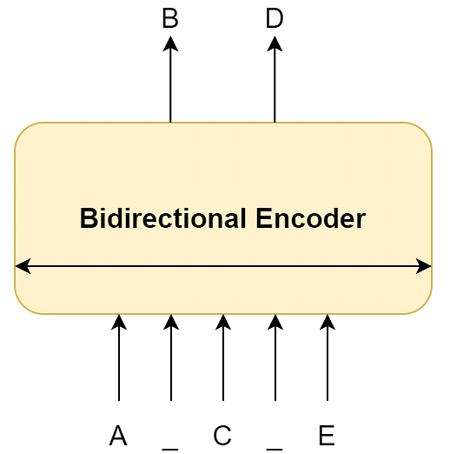

*Figure 4.1: The Bidirectional Encoder in BERT*

Though BERT was trained using a token mask, BART enhances the BERT encoder in the pre-training stage. After obtaining the tokens and sentence-level representations of the input text sequence, the decoder must interpret them to match the output destination. However, using similarly designed decoders can lead to poor performance in next-set and token prediction tasks, as the model relies on more extensive prompts. In such cases, the model architecture can be adequately trained to generate the following word by examining only the previous word in the sequence, as with commentary from Google News.

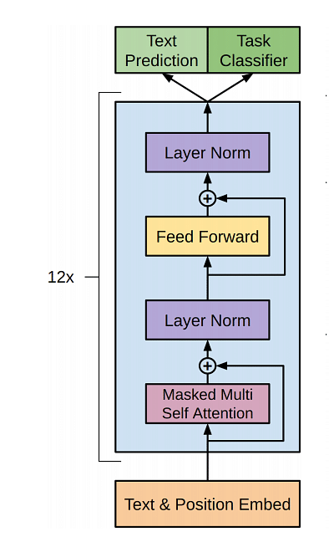

*Figure 4.2: The GPT Layering Architecture*

BART also supplements the GPT-1 model, which uses a similar architecture to standard transformers' decoders. As the GPT model stacks 12 such decoders in a sequential ordering, learning solely from past tokens can affect the computation of current tokens. The architecture is shown above in *Figure 4.2.* The GPT decoder also uses masked multi-head self-recognition blocks and feedforward layers.

GPT, and thus BART by definition, employs a semi-supervised learning approach. First, the model is pre-trained on token 't', and the current token is calculated looking back past 'k' tokens. This is done unattended against a vast corpus of text to allow the model to "learn the language".

$$L_{1}\left(T\right)= \sum_{i}{\log{P\left(t_{i} \right| t_{i-k},…,t_{i-1}; θ})} (1)$$

*Equation 4.1*

Then, to make the model robust to a particular task, we run the model in a supervised way to maximize the label "y" probability given the feature vectors x1...xn, i.e., the fine-tuning process.

$$L_{2}\left(C\right)= \sum_{x, y}{\log{P\left(y \right| x_{1},…,x_{n}})} (2)$$

*Equation 4.2*

Combining the above two equations, *Equation 4.3* is provided wherein lambda is a learned, weighted parameter for controlling the degree of language modeling.

$$L_{3}\left(C\right)= L_{2}\left(C\right)+λL_{1}(C) (3)$$

*Equation 4.3*

*Figure 4.3* below shows how an autoregressive decoder processes its input. Despite separating the decoder and the encoder, the input parsed to the decoder remains to be an embedding of the original text strings. BART, therefore, combines a bidirectional encoder and an autoregressive decoder to create a denoising autocoder architecture. Based on these two components, the final BART model is depicted in *Figure 4.4*.

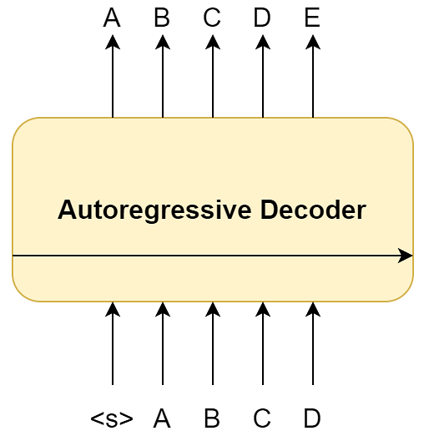

*Figure 4.3: The Autoregressive Decoder*

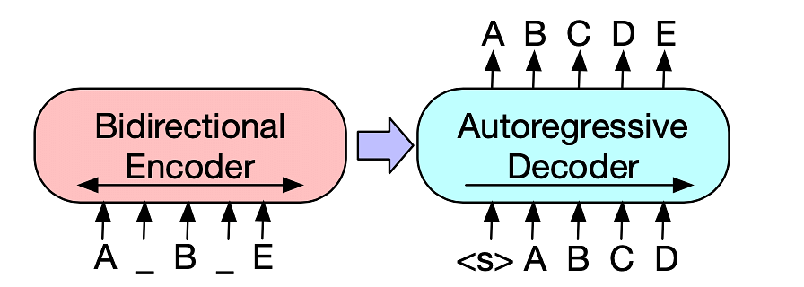

*Figure 4.4: The BART Architecture*

The input sequence is now finally a masked (or noisy) variation of [ABCDE] transformed to [A[MASK]B[MASK]E]. The encoder observes the entire sequence and stores a high-dimensional representation with bi-directional information. The decoder then takes these computed vectors and recursively predicts the next helpful token. Lastly, training is done by computing and optimizing the negative log-likelihood associated with the target sequence [ABCDE].

## 4.3. Model Implementation

The ‘bart-large-cnn’ model used for this project had many advantages; its BERT-like and GPT-like features made it resilient to noisy real-world data. In the context of this project, this data pertained to historical information about the match and player substitutions, information that a match summary should not contain. Moreover, since the language model was fine-tuned on over 300,000 unique news articles written by journalists at CNN News and Daily Mail, the model was best suited for text summarization (extractive and abstractive).

Yet, the preliminary testing indicated high similarities between the BART-generated and sample commentaries. Furthermore, despite no incomprehensible text production during reporting, the model showcased limited feature engineering. It was unsuitable for text generation that required domain-specific knowledge of the football sport, and as a result, it was prone to produce inaccurate or ambiguous commentary (see *Section 5.3.1*).

To overcome these challenges, GPT-3 was used as an intermediary filter to generate paraphrased text from live commentaries. In addition to being one of the largest language models with 175 billion parameters, GPT-3 strongarmed its few-shot learning and zero-shot learning capabilities to learn from limited training data. Hence, this language model eliminated the likelihood of BART generating summaries copied word-for-word from the original data sources and producing original, unique outputs that were distinguishable in writing but simultaneously synonymous in meaning. However, GPT-3 is not pre-trained on data after November 2021, let alone the 2022 World Cup; thus, to produce factually accurate and comprehensible text without diminishing sentence meaning, GPT-3 was fine-tuned to suit the needs of the project.

The secondary research conducted revealed no available datasets for text-to-text generation of sports commentaries. While live-oral commentaries may be parsed through an audio-to-text model to generate written articles subsequently, access to audio commentaries is highly restricted. In addition, the ‘robots.txt’ files (i.e., the terms and conditions for website usage by bot users) of many popular websites, such as Reuters, prohibit web-scrapping large amounts of data by law. Thus, existing datasets of paraphrasing corpora were sought after to train GPT-3 further to suit the needs of this final-year project.

The Quora Question Pairs dataset (Iyer et al., 2017) offered an exhaustive list of 400,000 sentential equivalent pairs. Unfortunately, upon further consideration, this dataset was disregarded as the sentence pairs revolved around the linguistic components of a question, such as variations of interrogative words and auxiliary verbs. This dataset was not ideal for written sports commentaries that seldom contain questions.

On the other hand, the TaPaCo dataset (Scherrer, 2020) is a multi-language database containing over 1.9 million sentences and is constructed from identical sentence pairs in over 73 languages. While only the English language pairs were preprocessed, they offered insightful training data to fine-tune the Curie GPT-3 engine. It is worth mentioning that the fine-tuning process involved formatting data as per OpenAI’s mandatory standards in Java Script Object Notation Lines (see *Appendix C*). Furthermore, although Curie is only the second most powerful engine, it provides a very reasonable balance between performance and training costs. Davinci – which is even more potent than Curie given that it has been trained on 13 billion parameters as opposed to Curie’s 6 billion – requires significantly more computational resources and is thus inordinate for this final-year project.

# 5. Results and Analysis

## 5.1. Product Testing

### 5.1.1. Linguistic Assessment (Quantitative)

The quantitative testing for the generated commentaries was scheduled via BLEU scores in the interim report, an approach described in *Section 3.2*. However, the severe limitations revealed the need for a sentence transformer to evaluate the written articles on semantic and linguistic meaning instead of the structural formation of sentence fragments and parts of speech. The articles for all 64 matches of the FIFA World Cup yielded an average semantic similarity score of 0.504 (rounded to 3 decimal places). A low to medium figure is to be expected as besides the information overlap in the reference (i.e., written report text retrieved from Google Search results) and the candidate (i.e., the natural language generated text), most parts-of-speech and sentence fragments such as the ordering of words are mutually exclusive since the NLG model paraphrases the original raw data using GPT-3 and then summarizes the generated text using BART. It was hypothesized that the semantic similarity scores would be lower than 0.75, given that the vocabulary and sentence structure intersection between the reference and learned English language candidate is eliminated by the GPT-3 paraphraser.

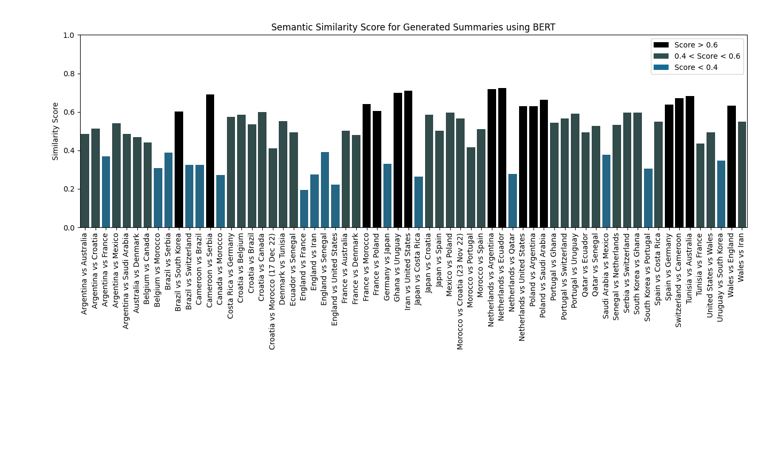

*Figure 5.1: Similarity scores between the sample and generated commentaries*

As seen in *Figure 5.1*, a majority of the generated summaries have a semantic similarity score larger than 0.4: 49 out of the 64 world cup matches scored above the specified threshold. At the same time, all commentaries scored under 0.8, a positive indication that the generated text is not deciphered word-for-word from the original data source (live commentary updates). These observations can be attributed to the hyperparameters of the fine-tuned curie engine from GPT-3. By controlling the sample temperature (range 0 to 2) to 0.6, the NLP model produced more focused and deterministic text with a small degree of randomness. At the same time, the nucleus sampling values were set to default to keep tokens with high probability mass and generate articles that were factually correct. Lastly, the word tokens generated by BART were truncated at 200 tokens, primarily to ensure that the written article does not exceed the established word limit.

The model employed to calculate the similarity scores – SBERT (Sentence-BERT) – is a fine-tuned version of BERT. The “all-MiniLM-L6-v2” model (Devlin et al., 2018) is a sentence transformer that utilizes the underlying BERT deep learning model to convert the written commentaries into vector representations, which thus allows it to capture semantic as well as contextual information and inferences from the text. The model, which has been pre-trained on 1,170,060,424 tuples from datasets ranging from Wiki Answers to Stack Exchange, hence results in more accurate meaning-based comparisons between texts as opposed to traditional comparison methods such as text classification and information retrieval. SBERT’s Siamese and triplet network architectures produce high-quality sentence embeddings, which subsequently categorize semantically similar sentence fragments from dissimilar ones. The underlying architecture demarcates a small distance to a pair of similar sentences; it does the opposite for dissimilar sentences to create positive and negative pairs and ultimately optimize the model. This technique is known as “contrastive learning”.

A sentence-transformer model like SBERT was used particularly because these models are pre-trained on sentence-pair tasks and thus more suitable for semantic similarity tasks (Devlin et al.,2018). In fact, a by Vaswani et al. (2018) has shown that fine-tuned BERT-base models yield better performance than GPT and BART for some natural processing tasks, specifically semantic similarity.

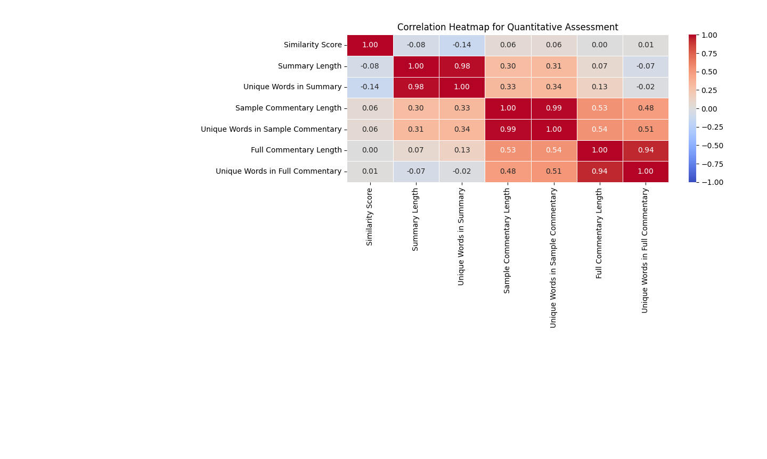

*Figure 5.2: Correlation Heatmap*

In addition to a numeric score of semantic similarity, the quantitative assessment of this report also focuses on finding relationships between word usage. As expected, there is a strong positive correlation between the model-generated summary length, sample commentary length, full live commentary length, and the number of corresponding unique words in each of these texts. Furthermore, the generated summary length is very weakly positively related to the sample commentary length, and there is no correlation between summary length and full commentary length. Both of these evaluations indicate that the generated commentary is well within the specified constraints and has not faltered or been influenced by variance in input data.

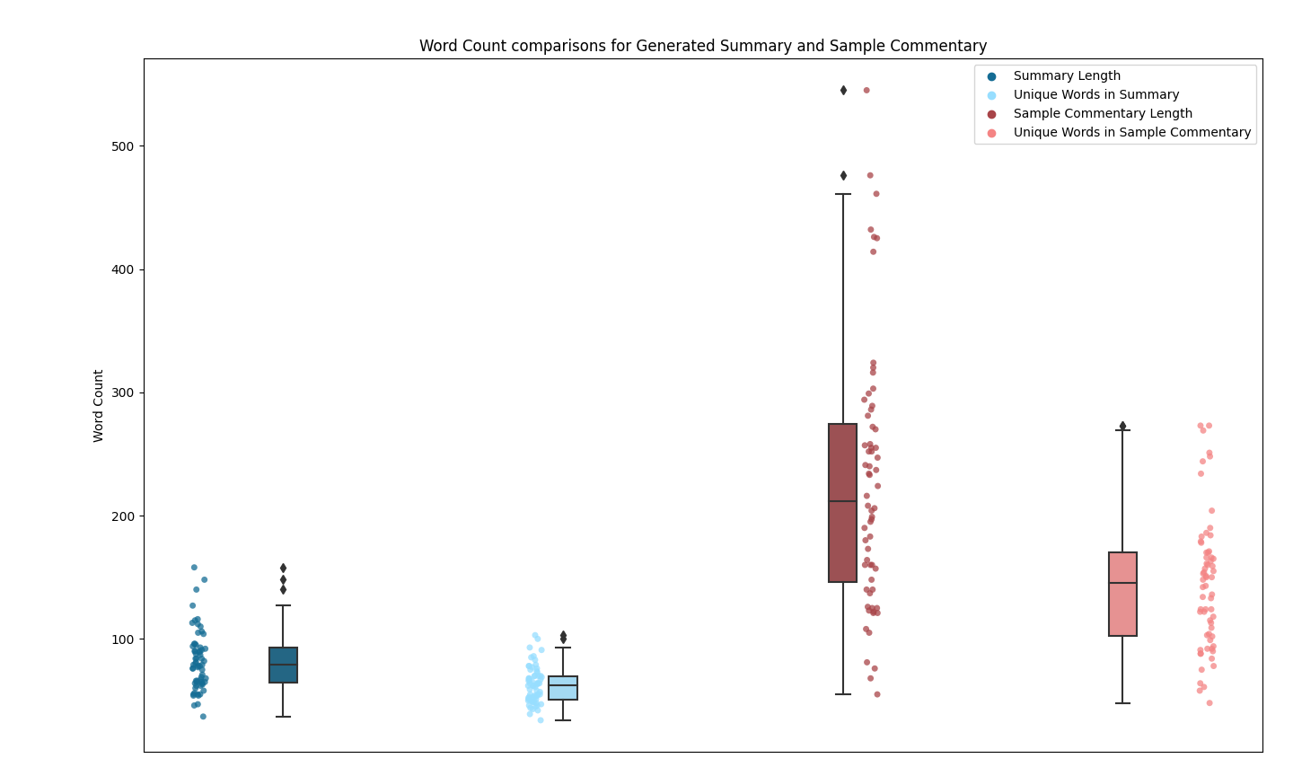

*Figure 5.3: Word counts of sample and generated commentaries*

Finally, the box-and-whisker plot in *Figure 5.3* compares the variation in word counts for natural language generated and sample text. All generated commentaries are under 200 words, with a median of 79; the 25th percentile is 64, and the 75th percentile is 96. In addition, the commentaries are also diverse in vocabulary and diction, as almost 75% of the words used are unique on average (the median number of unique words in the summary is 61). On the other hand, the sample commentary data varies significantly more. There was a total of 7 sample commentaries that were outliers compared to the rest of the data. These commentaries produced a text greater than 400 words, a range that is more than double the specified criterion for a summary (200 words) specified in this project. However, upon a case-by-case evaluation, it was found that these commentaries were for matches with a significantly higher viewership (such as the world cup final game between Argentina and France) or high-scoring games (such as the 8 goal game between England and Iran that ended with a score-line of 6-2).

### 5.1.2. Subjective Assessment (Qualitative)

The qualitative assessment of this final year project is designed on a scale-based rating system. The survey criteria, in addition to the average score (rounded to the nearest whole number), are specified in the table below:

|  |  |
| --- | --- |
| Criterion (scale-based rating system) | Average score (from 53 participants) |
| Text Readability | 8 |
| Information Correctness | 7 |
| Text Clarity | 8 |
| Text Conciseness | 7 |
| Neutrality | 8 |
| Creativity and Vocabulary | 8 |

*Table 5.1: Qualitative Assessment Criteria*

To reduce any biased scoring from a specific demographic, the survey was distributed to a variety of target audiences, including:

* + English department professors at the City University of Hong Kong.
  + Football enthusiasts aged 14-21, 21-55, and 55+.
  + Avid readers.
  + University students of ages 18-29.

However, for the purposes of the assessment, all respondents were asked to categorize themselves into the following knowledge base:

* Native English Speakers and Football Enthusiasts.
* Non-Native English Speakers and Football Enthusiasts.
* Native English Speakers and non-Football Enthusiasts.
* Non-Native English Speakers and non-Football Enthusiasts.

It was unrealistic to collect survey data for all 64 matches of the world cup; thus, the following 4 games were selected (see *Figures 5.4-5.7* for the written summaries):

1. Argentina v France (the world cup final match, with around 1.5 billion views according to FIFA).
2. Portugal v Switzerland (is an example of a high-scoring knockout game; it ended 6-1).
3. Germany v Japan (is an example of a low-scoring but ‘exciting’ group stage game, which ended 2-1 in the final minutes of the game).
4. Morocco v Croatia (is an example of a group stage game that ended in a draw).

The games were particularly selected for their variety in final scores and the stage of progression in the World Cup with the intent to collect subjective data on a diverse range of matches. The collected data is visualized as violin plots; these graphs cipher features from box-and-whisker plots and kernel density plots to depict key statistics and variable density. The graphs in *Figures 5.4-5.7* also illustrate the density of respondents choosing a specific score for given criteria. The visualizations represent the median grade, upper quartile (75th percentile), and lower quartile (25th percentile); the kernel density estimation shows the distribution of the data, wherein wider curves correlate to higher probabilities of choosing a particular grade and vice-versa (Carron, 2021). In other words, these probabilities also estimate the likelihood of specific criteria scores.

The data collected from all survey respondents is analyzed below:

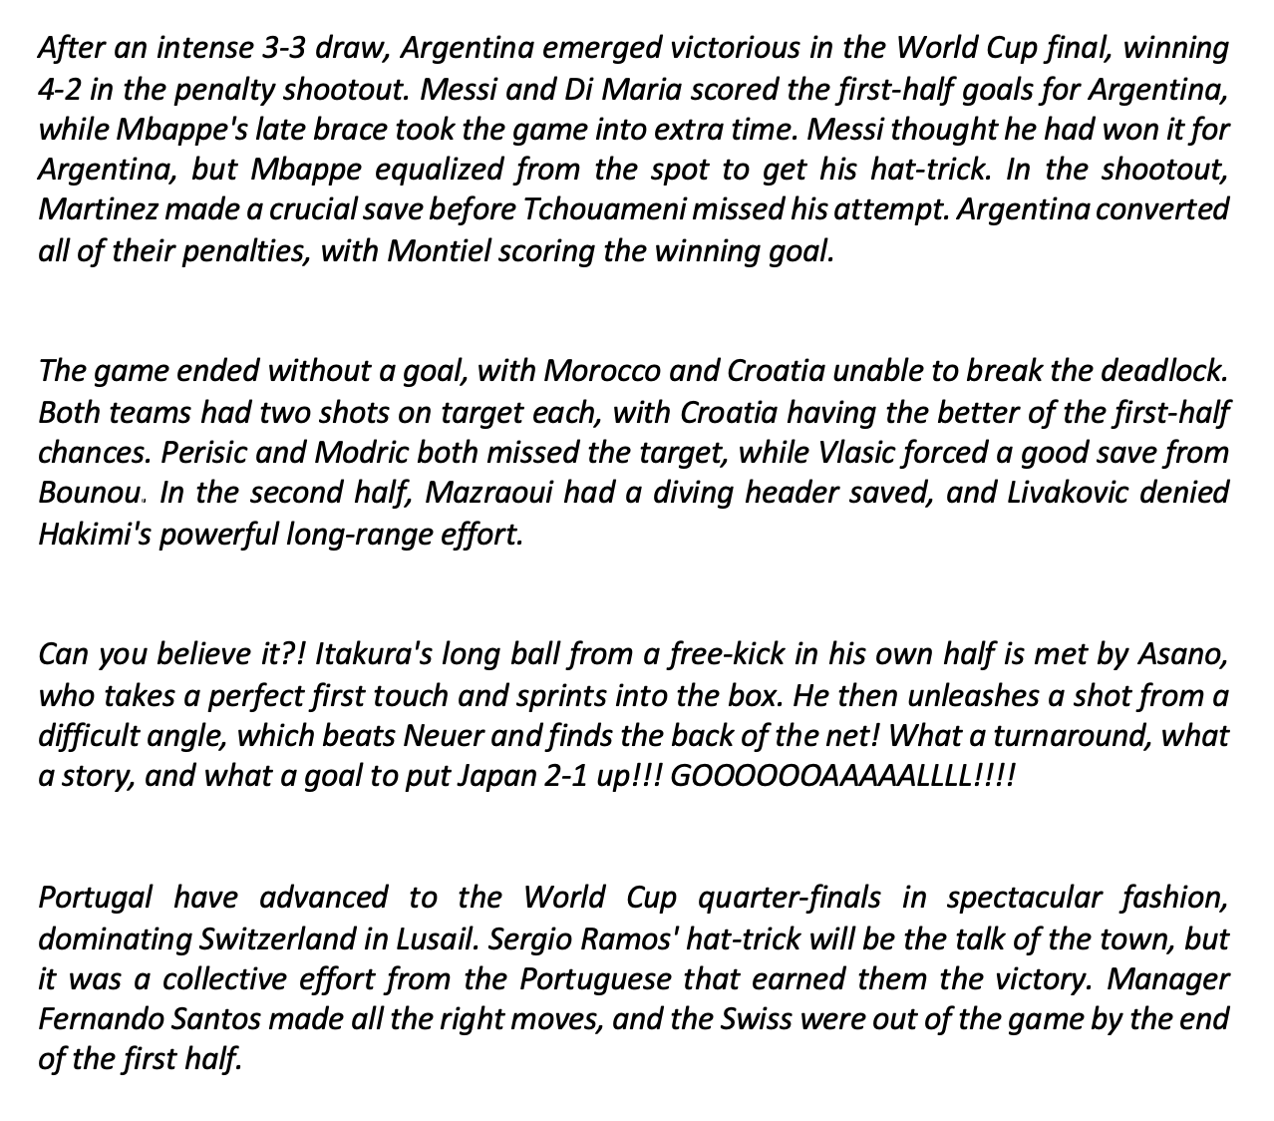

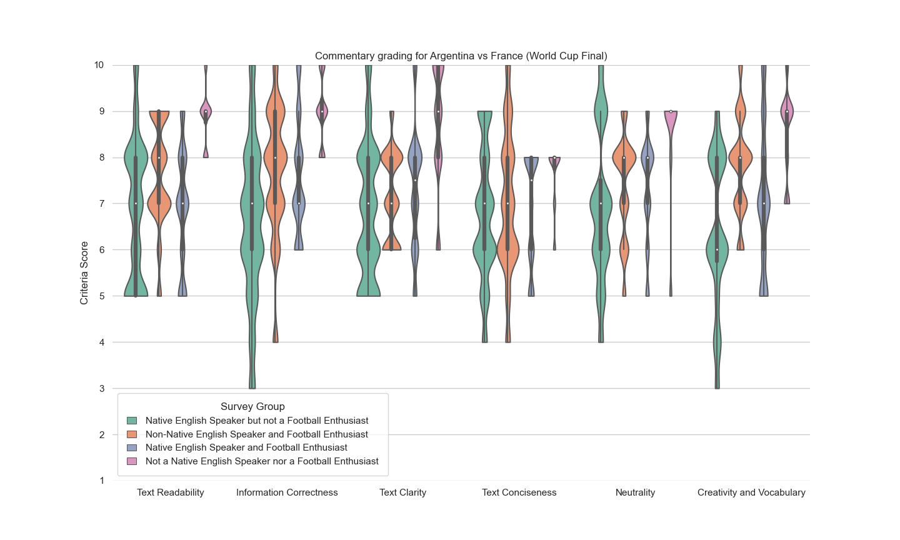

*Figure 5.4: Sample commentary and survey data for Argentina vs. France*

Non-native English speakers and non-football enthusiasts gave considerably higher scores for text readability, information correctness, and creativity and vocabulary than other survey groups. Furthermore, as *Figure 5.4* depicts, there is considerably less deviation in responses of this survey group as opposed to the range of responses given by native English speakers and football enthusiasts.



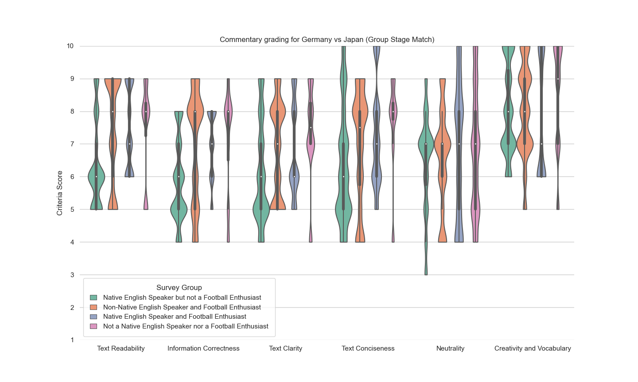

*Figure 5.5: Sample commentary and survey data for Germany vs. Japan*

The grading for Germany versus Japan had the highest range and variance on average compared to data collected for all 4 NLP-generated commentaries that were assessed by the demographic. The interquartile ranges for text neutrality ranged by as much as 6 points, even though all 4 survey groups assessed the criterion with a median score of 7.



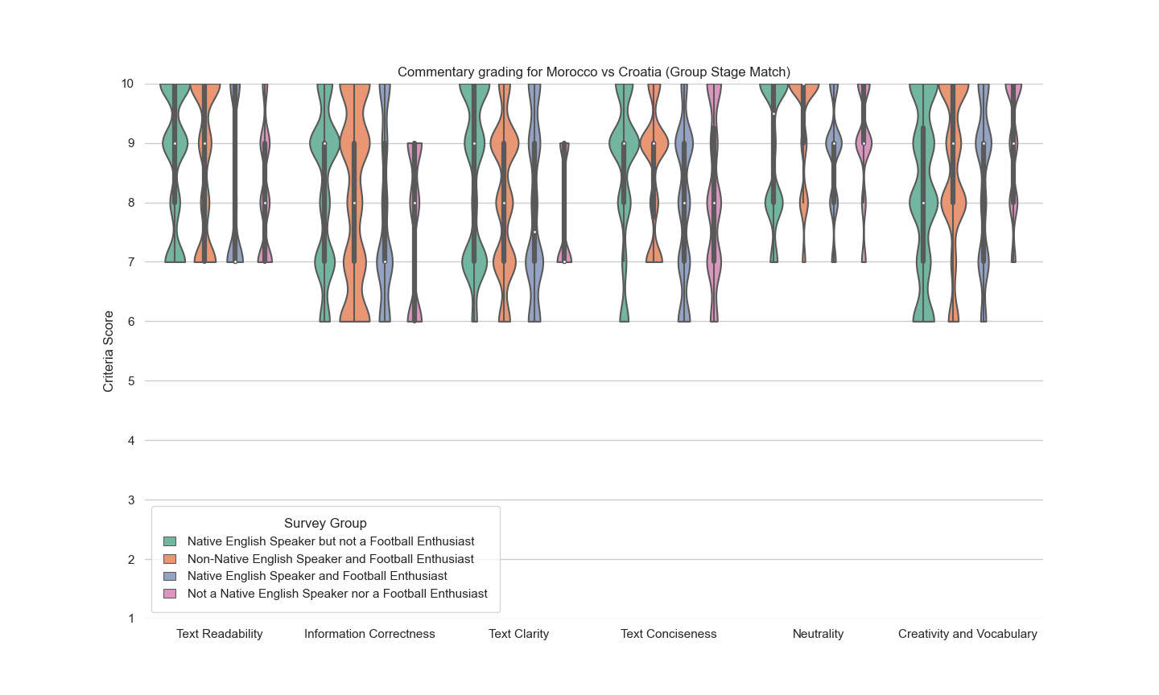

*Figure 5.6: Sample commentary and survey data for Argentina vs. France*

Despite the low scoring result for the game, the creativity and vocabulary metric received high scores from a majority of the 53 survey participants. From a comparative standpoint, the written summary for Morocco versus Croatia also had the highest average scores for all 6 criteria and the lowest variance and difference in interquartile ranges.



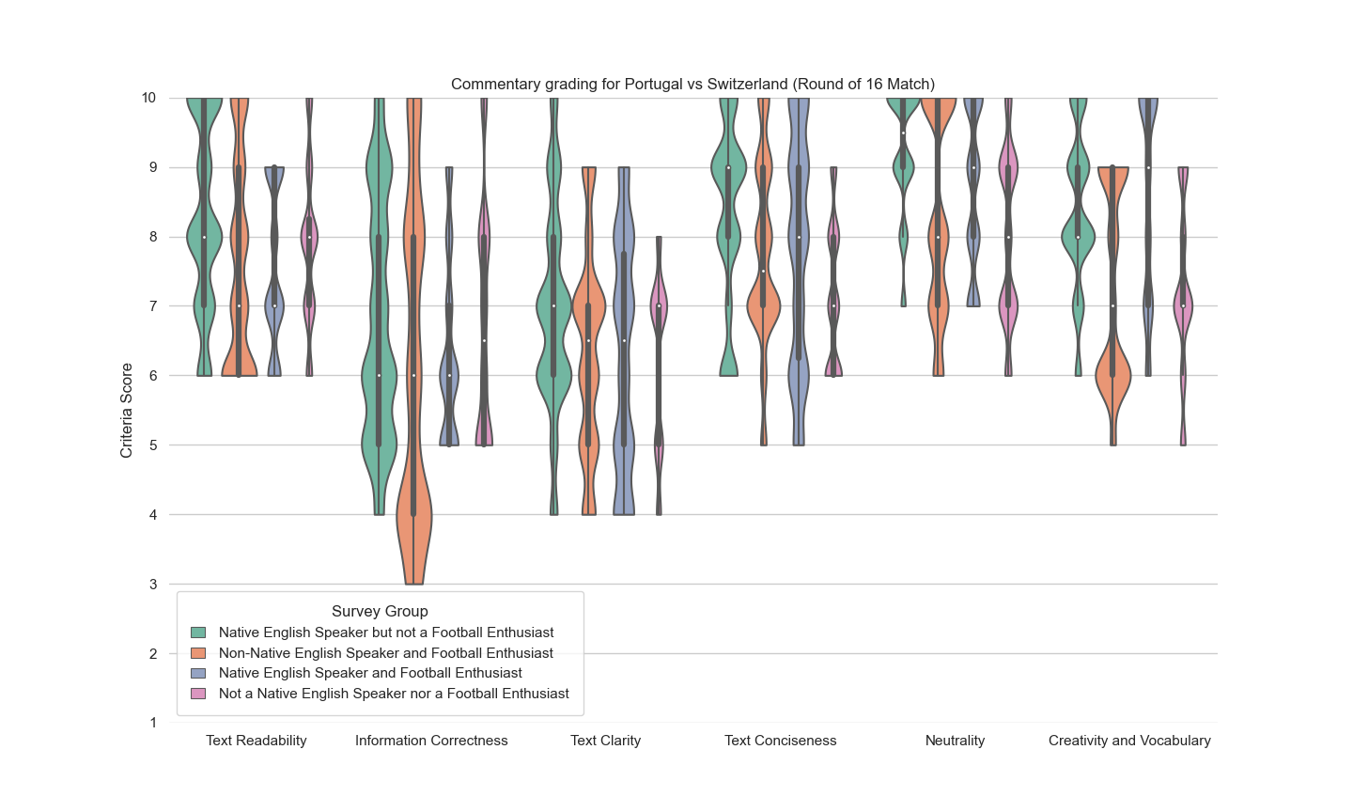

*Figure 5.7: Sample commentary and survey data for Portugal vs. Switzerland*

The survey responses for Portugal versus Switzerland were the most unique. The generated commentary itself was ambiguous, as the generated text seemed to indicate that Sergio Ramos, a Spanish defender, scored a hattrick instead of the Portuguese forward Goncalo Ramos. Such an ambiguity stemmed from GPT-3’s text-to-text translation model, potentially because GPT-3 has been pre-trained on data preceding the 2022 World Cup: until November 2021. As a result, the transformer confused the Portuguese player with the same surname as his Spanish counterpart. Subsequently, the scores for information correctness for this commentary were significantly lower, especially from non-native English speakers and football enthusiasts. The match commentary was Portugal versus Switzerland was specifically selected to evaluate the effect of textual ambiguity and incorrect information for the target audience. Even though this example was a standalone exception in the 64 match commentaries, the presence of such an outlier highlights that transformer models, such as GPT-3, may not provide entirely accurate information.

## 5.2. Website Testing



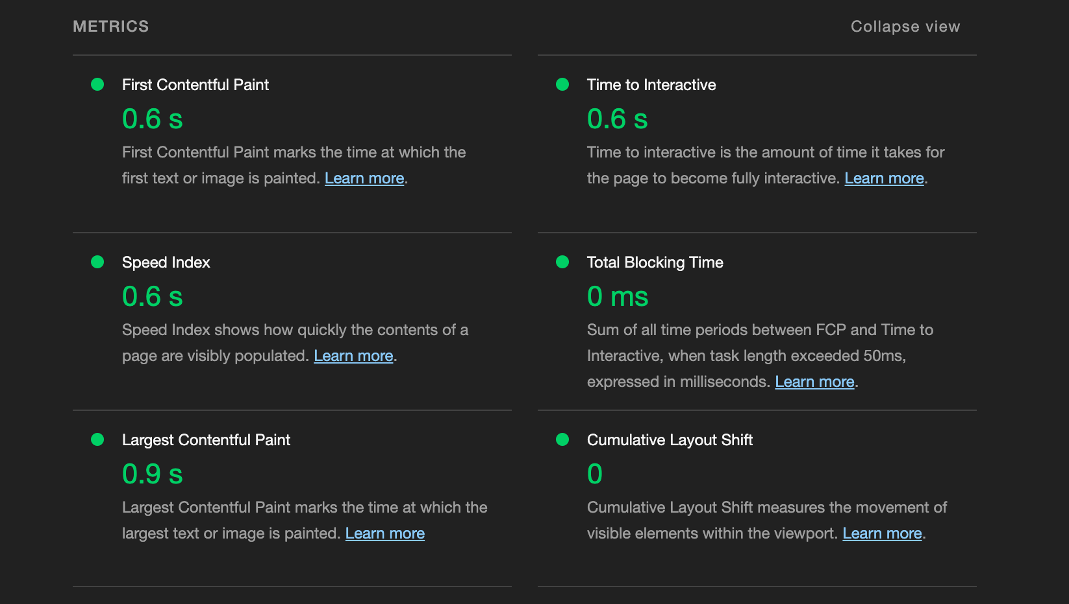

*Figure 5.8: Lighthouse assessment*

The website, i.e., the end product seen by the users, also needed evaluation, given that it is the end product seen by the users. The website's functionality was graded using an open-source tool called ‘Lighthouse’. This tool, developed by Google, audits the quality and performance of web pages. The parameters for assessment included the following metrics:

* + Accessibility
  + Performance
  + Best practices

As seen in *Figure 5.8*, the website for this final year project ranks high per Lighthouse assessment, though there is room for improvement in Accessibility.

## 5.3. Discussion of Articles Generated

### 5.3.1. Evaluation of Planned and Implemented Methods

The initial plan formulated in *Section 3*exercised the SimpleNLG toolkit in addition to an encoder-decoder model that generated written commentary as a predictive text. This approach was overtly reliant on sentence templates formulated from factual data, which were then used to generate natural language text. The Generative Pre-Trained Transformer 2 (hereafter GPT-2) model was initially selected to generate the written commentaries, seemingly the ideal choice given that the open-AI model was specially trained to guess the next word given a prefix input substring. However, an evaluation to generate sports commentaries using the same model proved futile predominantly because of the factual inaccuracies outputted by the model. These inaccuracies are:

* 1. Incorrect year for the competition (2014; the edition in use is 2022).
  2. Incorrect location for the match (Istanbul; the match was played in Qatar).
  3. Inaccurate number of World Cups cited for France (1; France has won the World Cup twice).
  4. Inaccurate competition cited (FA Cup; the competition considered is the FIFA World Cup).

Though the predictive text is grammatically and syntactically correct, barring the incomplete final sentence due to a word truncation limit, the misrepresentation of facts and information deems the GPT-2 impractical in this scenario, as depicted in *Figure 5.9*. The model output is highlighted in blue, while the input prefix string is labeled black. Thus, the use case for this model is better suited for casual language modeling and creative writing implications.

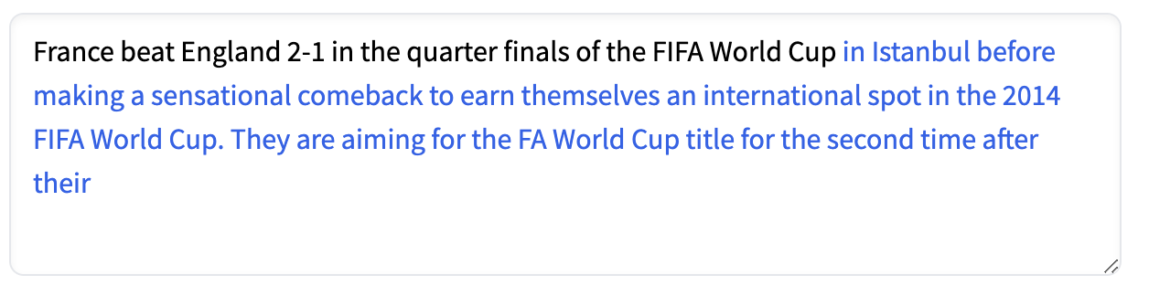

*Figure 5.9: Sample commentary snippet based on GPT-2.*

This final-year project ultimately implemented the BART model described in Section 4.2. The data collection method enumerated upon in *Section 4.1*yielded sample data that was sophisticated enough to produce legible text. Provided labeled and categorized sentences from Google News, the model could perform extractive text summarization to identify key points in the match and generate a match summary. The generated text was comprehensive and non-redundant, highlighting the critical semi-supervised learning approach the model employs to understand language. Nonetheless, there were still some ambiguities that needed amendment post-generation. For example, in the context of the World Cup quarter-finals between France and England and given an input of the text ciphered from Google Search for each of the 3 goals (first text box), the following output was generated (the second text box labeled in green):

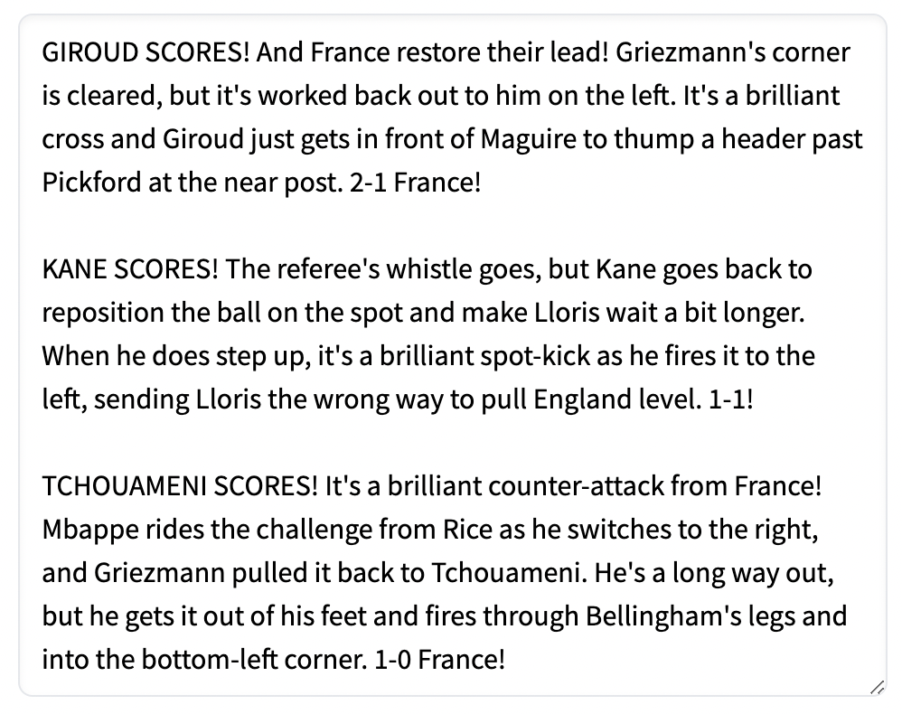

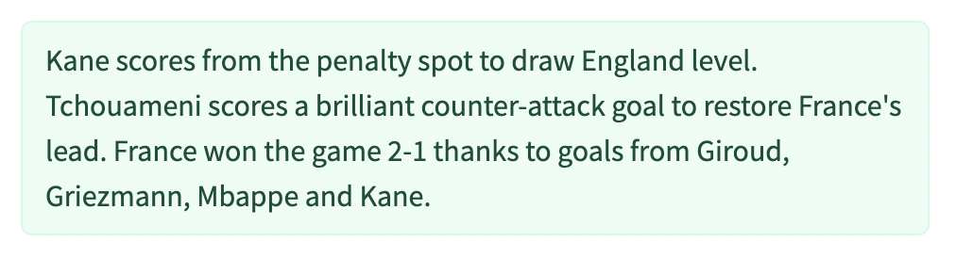

*Figure 5.10: Sample commentary summarized by BART.*

It is worth noting that Griezmann is not the goal scorer, even though the generated commentary suggests so. Such cases are thus corrected by tallying the generated text with the key-value pairs identified during the data collection process. Nonetheless, according to the qualitative assessment based on the initial survey responses, the generated commentary is more cohesive, comprehensive, and even “engaging”.

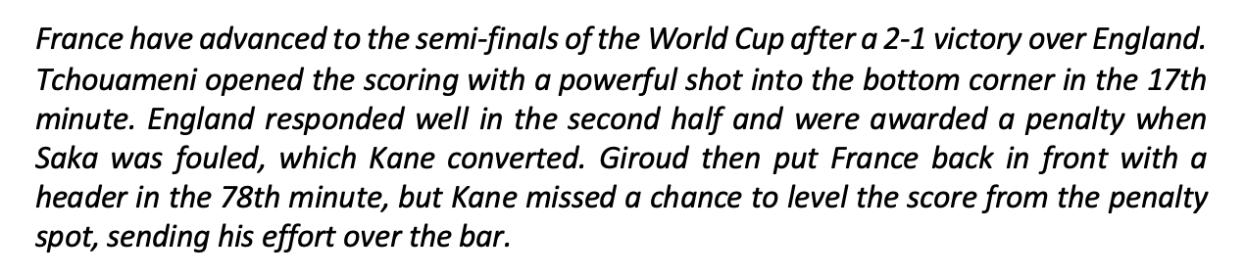

*Figure 5.11: Final written commentary sample*

The project implementation described in *Section 4.3* used GPT-3 as a text-to-text generation model to paraphrase and parse sample input. The intermediary text was inputted into the BART model that was fine-tuned for text summarization of news articles. The data collection schematic outlined in*Section 3.3* was unnecessary to generate written commentaries and, as a result, was not implemented for the final model. *Figure 5.11* depicts the final summary written by the natural language models for the example discussed in this subsection (see *Section 5.1.1* for more sample commentaries).

### 5.3.2. Practical Constraints

Although there is a lack of preprocessed data to train the model in the football FIFA World Cup context, some of the data is still readily accessible via web scraping. This is possible mainly because of the vast demand associated with the World Cup frenzy. Though there is still sufficient data generated for national-level games and even in-demand domestic league games, in a more practical sense, low-demand matches will likely not have any additional data besides the statistical information recorded in the match. The devised natural language model is expected to perform poorly in such scenarios. Given the absence of sentence strings, the BART model may not effectively perform text summarization and generation. Hence, for the time being, the use case of this model is restricted to in-demand games, i.e., matches wherein at least one update/ commentary is published for every 10 minutes in the game in addition to the foundational statistical information.

In addition, the legal laws imposed by news websites that provide live-match data limit the live data collection methods to Google Search. It is likely that the model will perform even better if more data could be either web-scraped from reporting sources or consolidated as a dataset for further refinement.

## 5.4. Future Scope

One of the more obvious ways to improve the model is to train BART to generate text on minimal input data. In other words, the model can be developed from scratch such that it can generate fully interconnected sentences solely based on information provided in steps *5c-5h* of *Section 4.1*. However, such an approach may be deemed impractical given that there is no substitute for a lack of written real-time data for football matches.

Consequently, a better approach would be to generate text from live oral commentaries during the match. While doing so solved the issue of live data collected, it also raises a complication in text classification given that oral commentaries are far from concise and thus need additional layers of filtering to disregard the noise data provided in oral commentaries.

Alternatively, it is possible to use an entirely data-to-text generation model that employs a Template-based approach. Herein, the system could use pre-defined templates to generate text based on modular data. However, such a design is unlikely to result in commentaries that unique and cohesive; all generated text is likely to fall under similarly worded sentence fragments and thus may not receive positive views from the end-users during qualitative assessment.

# 6. Conclusion

The findings of this final-year project demonstrate that sports commentary may be automated using Natural Language Processing tasks, namely the text-to-text generation and text summarization. 100-to-200-word text summaries for all 64 matches of the FIFA World Cup Qatar 2022 were produced by web-scraping Google Search results to update live-commentary (i.e., match timeline) data, which was subsequently construed to a fine-tuned Generative Pre-Trained Transformer-3 model to generate semantically equivalent sentence vectors. Finally, this text was keyed to a fine-tuned Bidirectional Auto-Regressive Transformer to produce the summary.

The resultant commentaries were evaluated using mathematical metrics and human evaluations. However, initial testing suggested that the Bi-Lingual Evaluation Understudy assessment was inaccurate for assessing the text as it focuses on word usage and syntax instead of meaning. As a result, the text was assessed by calculating the semantic similarity between the sample and generated commentaries using fine-tuned Bidirectional Encoder Representations from Transformers model. All 64 commentaries compared well against the metric. The sample 4 commentaries that were evaluated by human readers of different age groups, football knowledge, and language preferences scored either 7 or 8 out of 10 on a specified set of criteria that included assessment of text readability, correctness, clarity, conciseness, objectivity in reporting, and vocabulary.

Lastly, training on domain-specific football data can further augment the natural language generation models. The data itself may be collected and processed from live-oral commentaries. However, a template-based data-to-text methodology is advised to ensure that the models can generate reports for all types of football matches – including ones where oral or written commentary is not available. Nonetheless, such approaches must ensure that text quality is not forborne as an opportunity cost.

# 7. Appendix

Appendix A: Sample JSON Object (Correia, 2020)

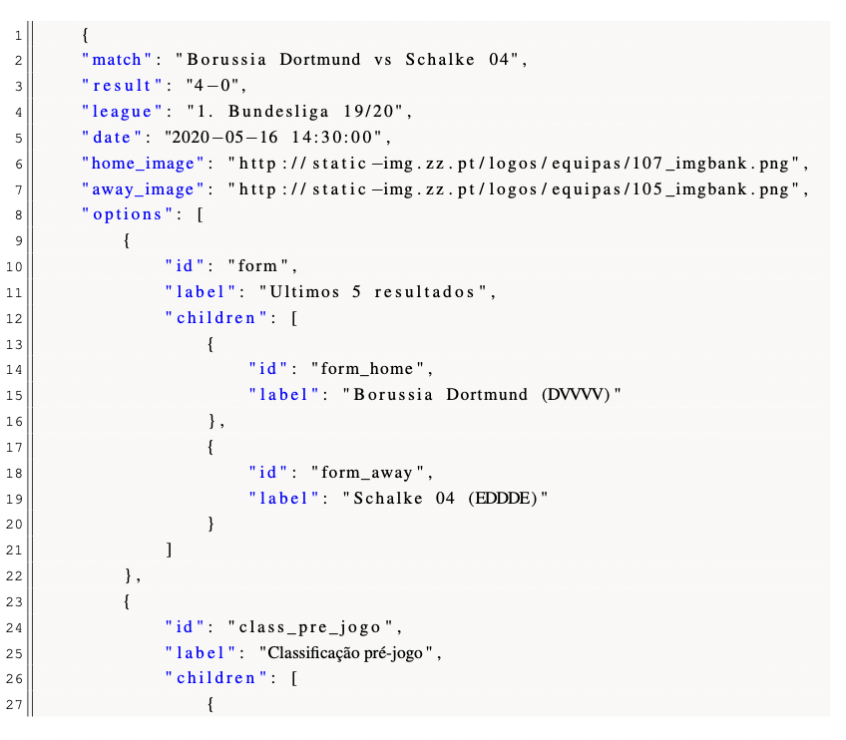

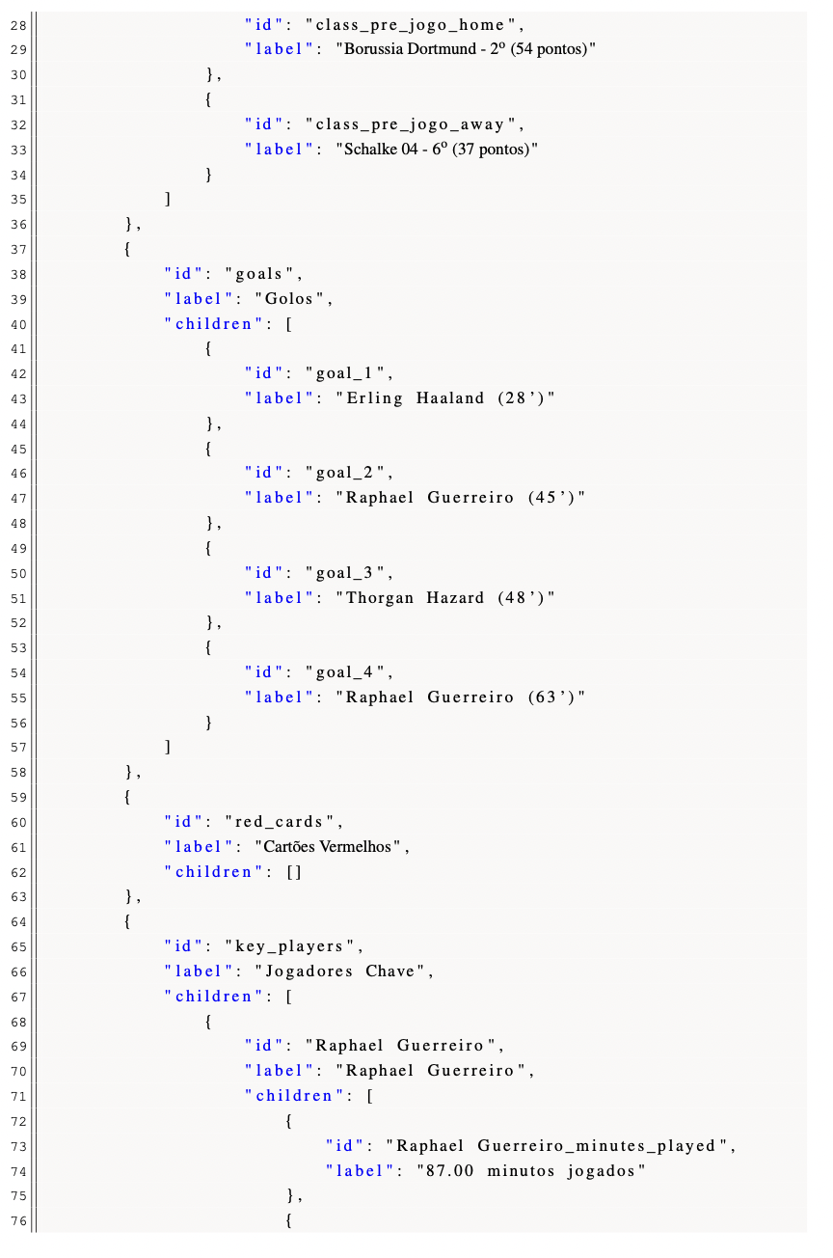



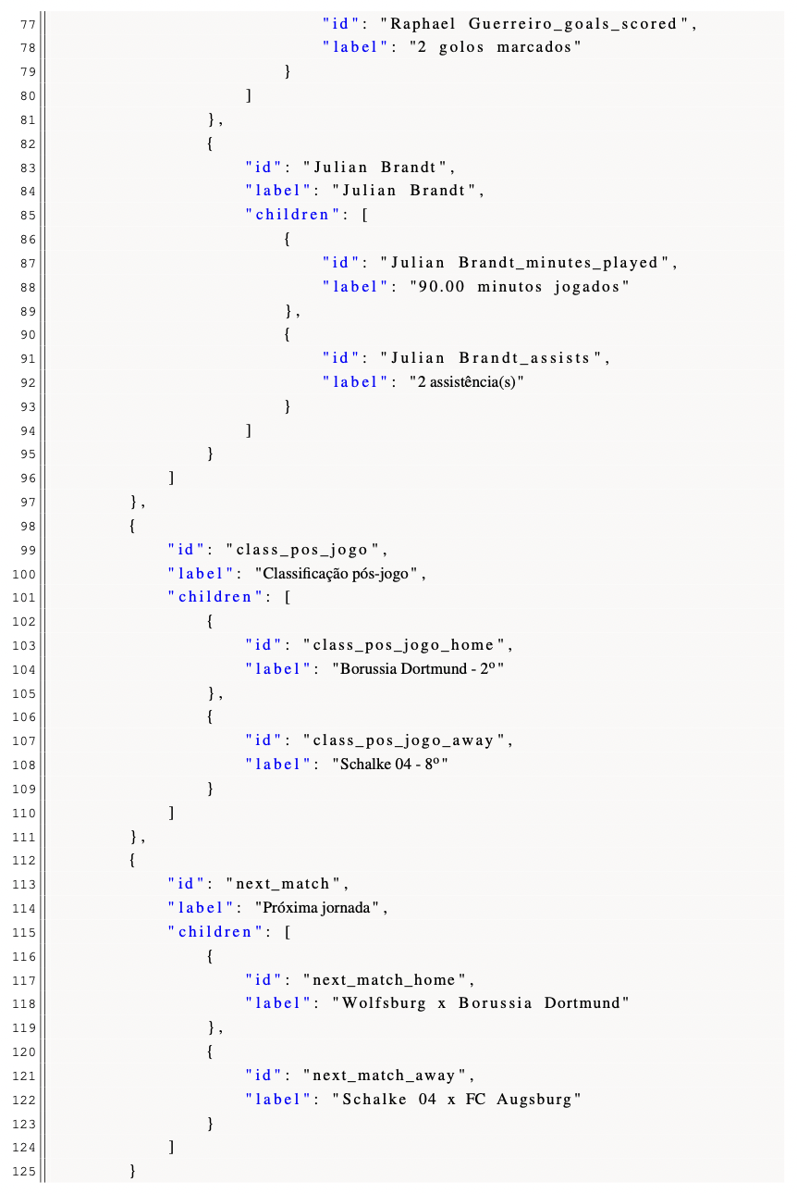

Appendix B: Sample Data Sources (adapted from the official Premier League site & Google Search)

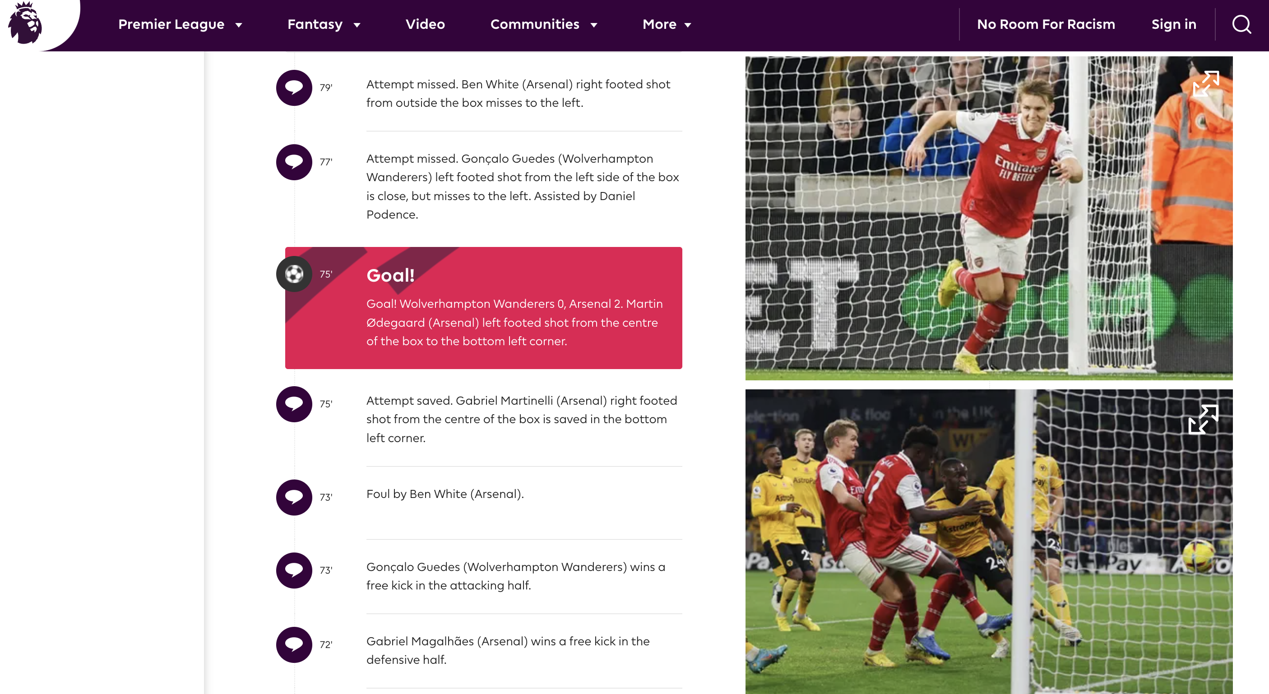

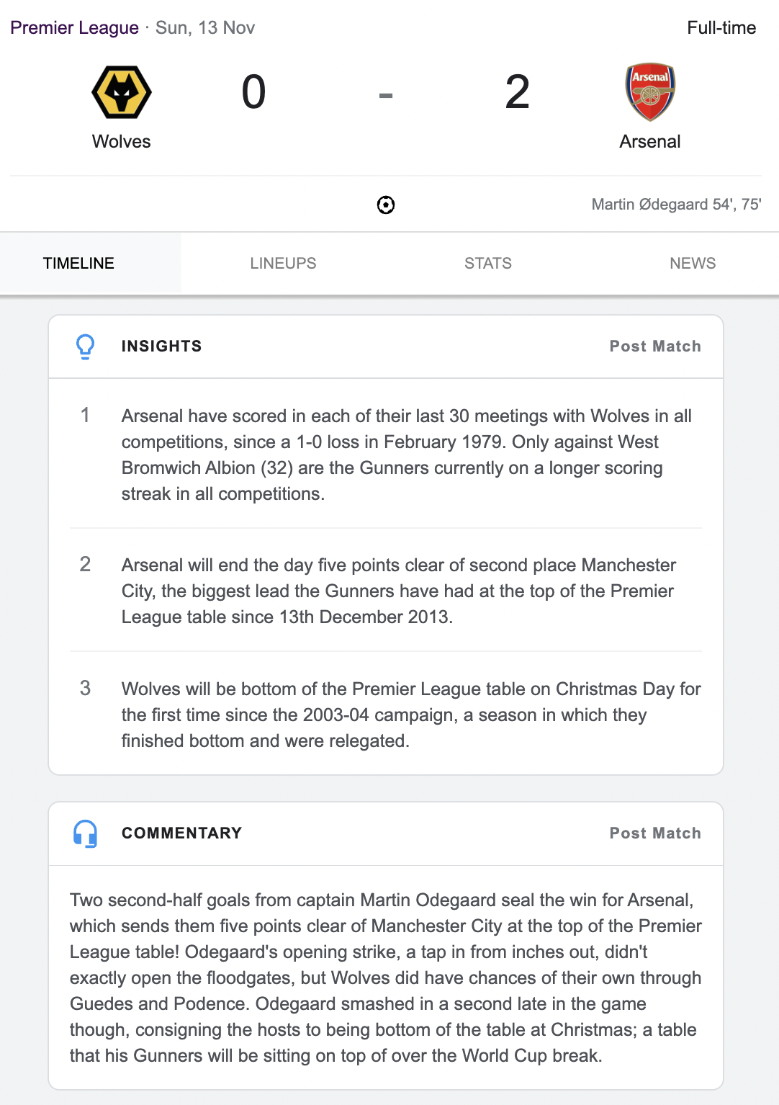

Appendix C: Snippet from a JSONL for fine-tuning GPT-3.

*Note every sentence pair's “prompt” and “completion” keywords. Furthermore, the former should end with a “. ->” while the latter requires a “\n” (newline character).*

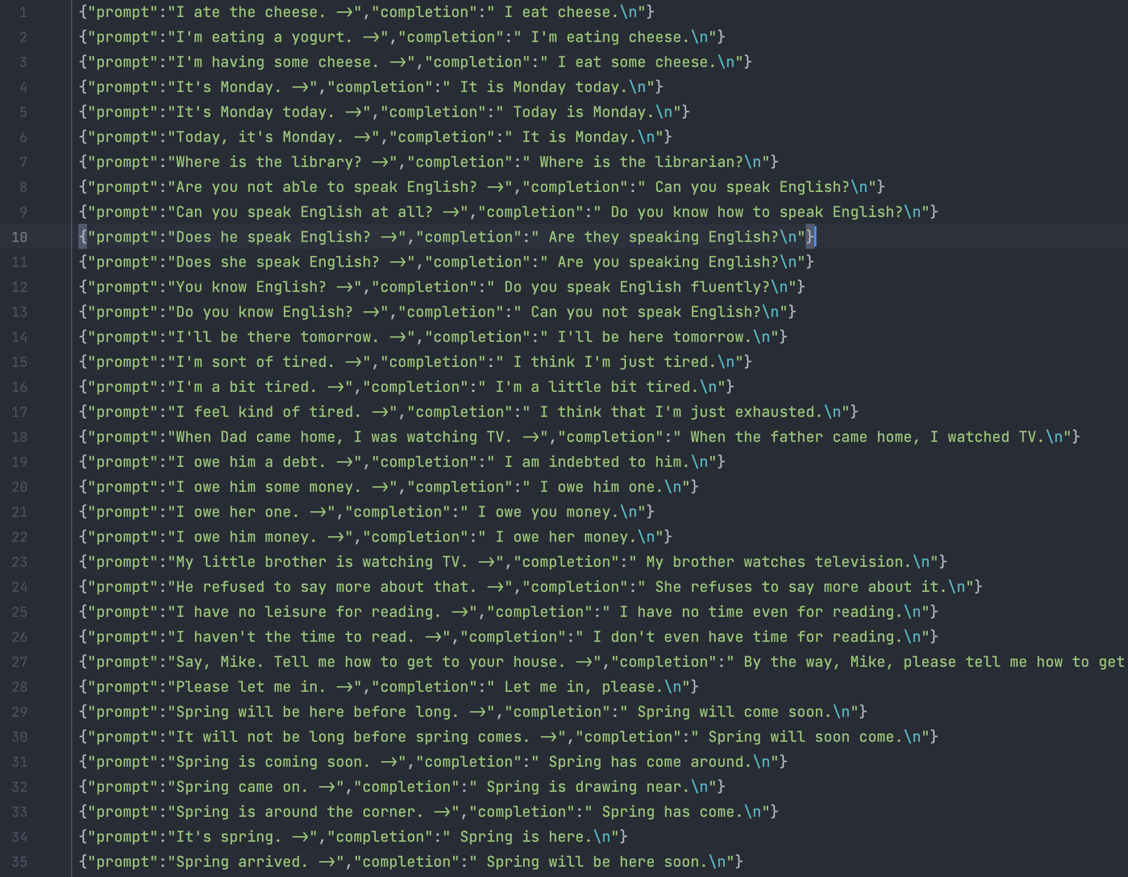

Appendix D: Project Timeline expressed as a Gantt Chart

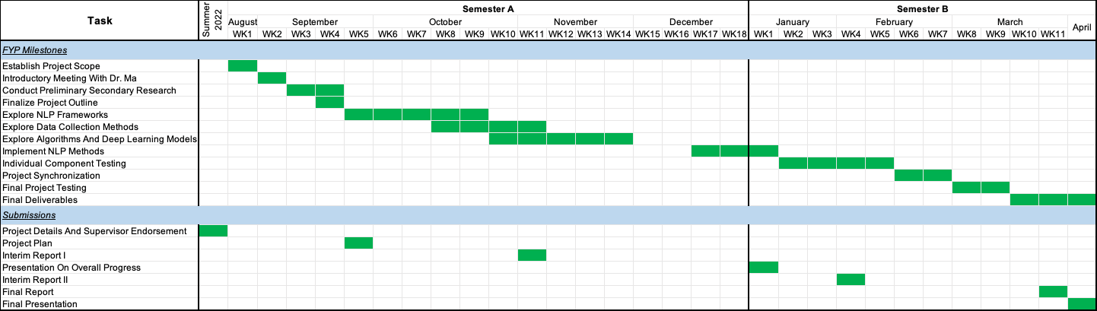

Appendix E: Monthly Logs

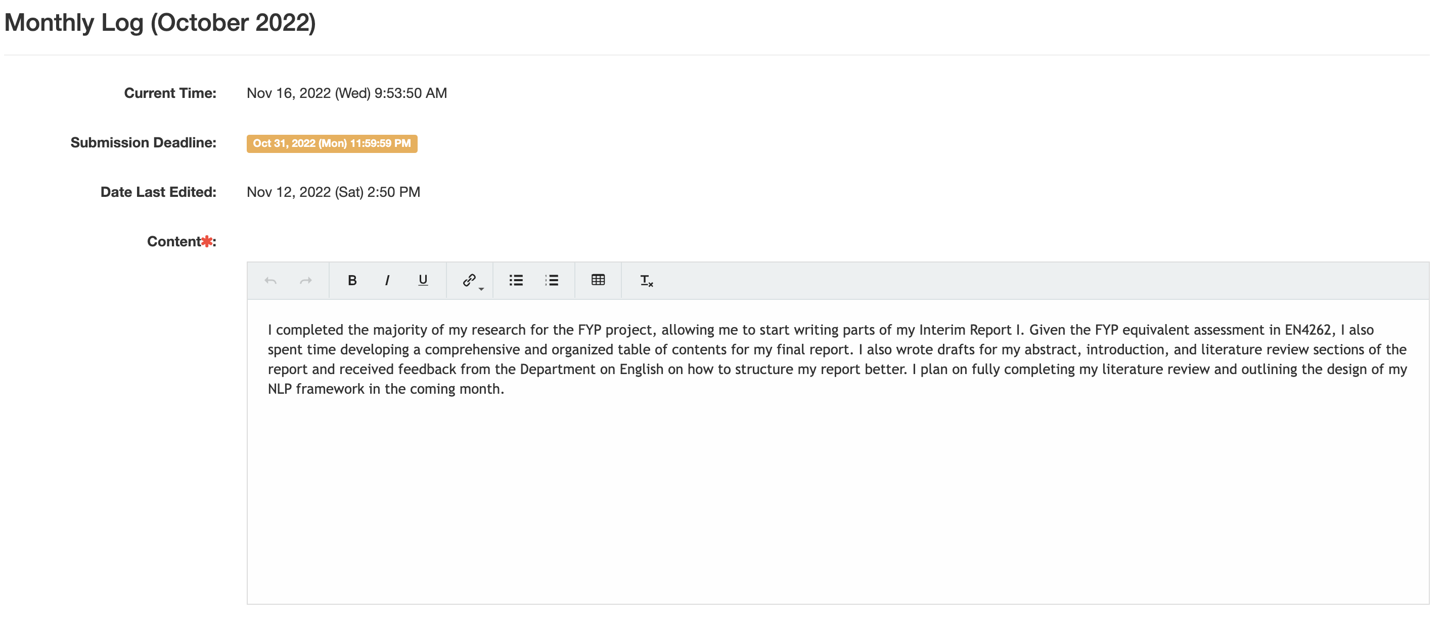

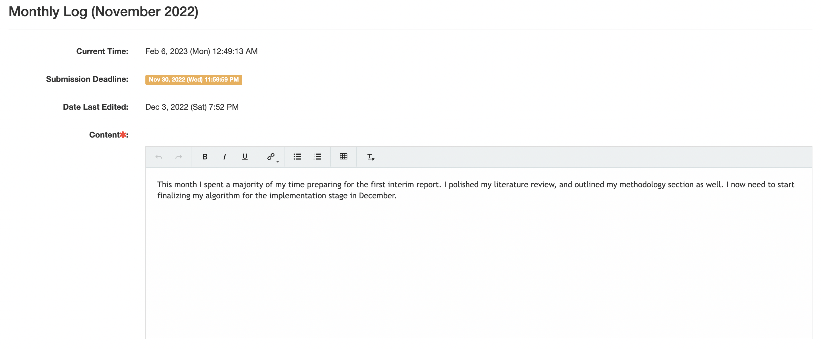

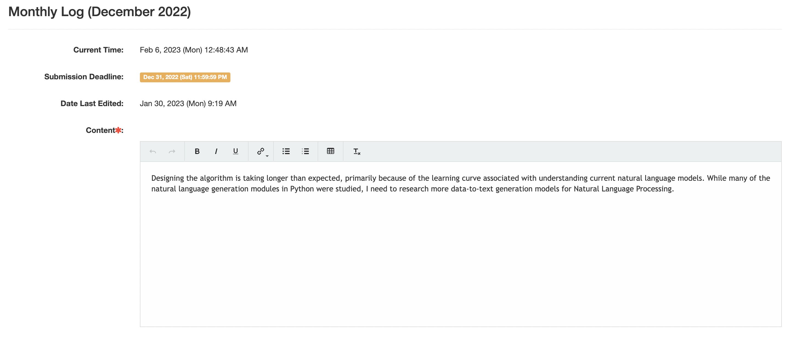

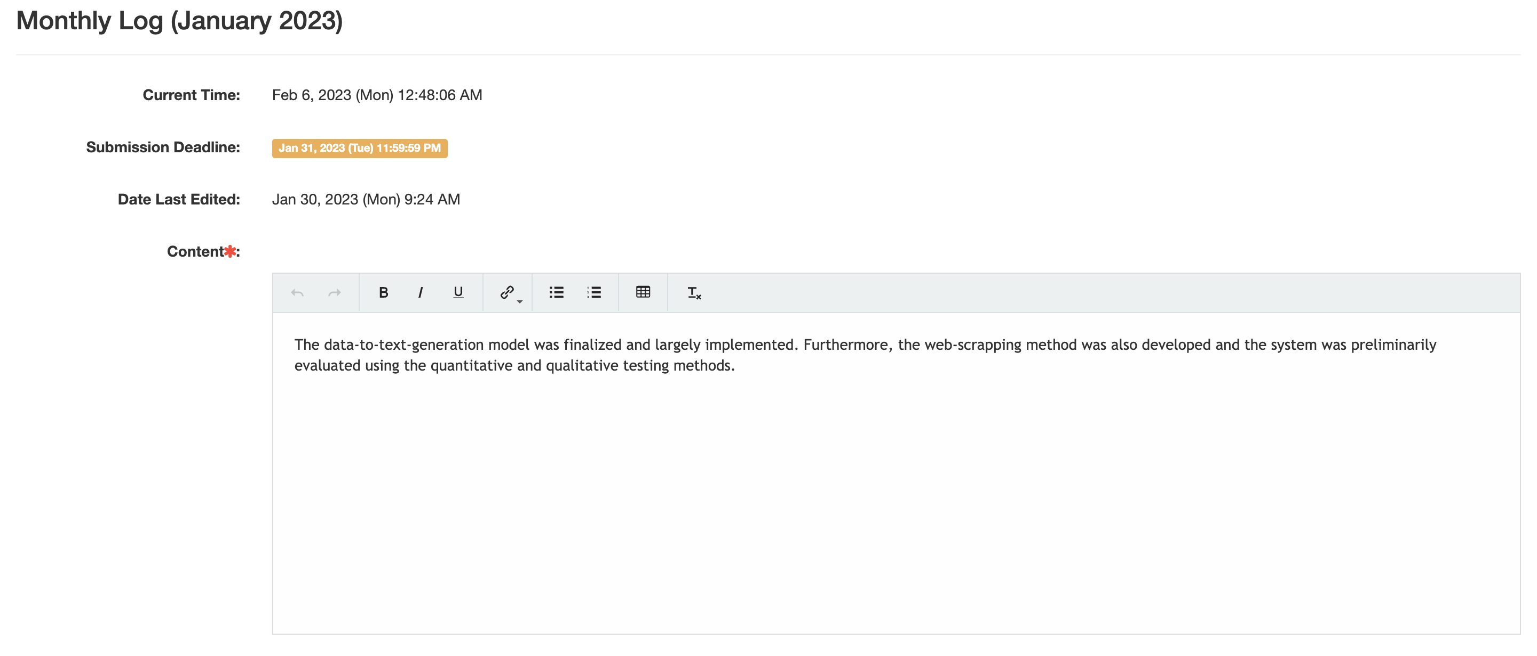

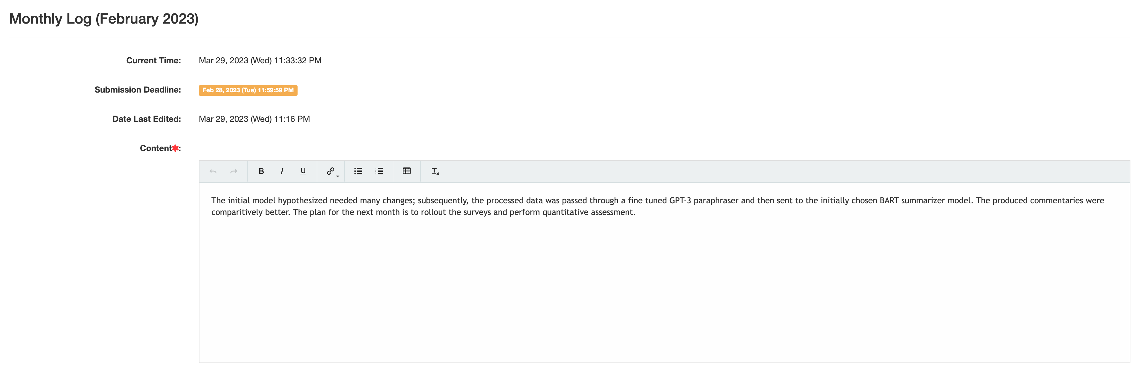

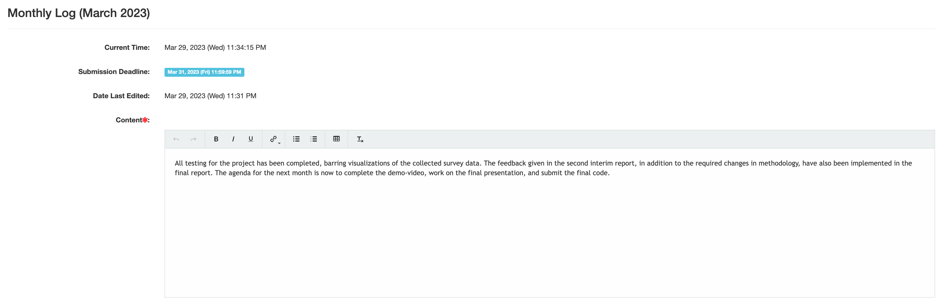

# 8. References

Carron, Joel. (2021, December 13). Visualizing distributions with violin plots. Mode. <https://mode.com/blog/violin-plot-examples/>

Devlin, J., Chang, M.-W., Lee, K., & Toutanova, K. (2018). BERT: Pre-training of deep bidirectional transformers for language understanding. arXiv preprint arXiv:1810.04805.

Dvorak, J., Junge, A., Graf-Baumann, T., & Peterson, L. (2004). Football is the most popular sport worldwide. *The American Journal of Sports Medicine*, *32*(1), 3–4. <https://doi.org/10.1177/0363546503262283>

Fort, R., & Fizel, J. (2006). The economics of sports and the economics of multi-billion dollar industries. Journal of Economics and Finance, 30(1), 1-4. <https://link.springer.com/article/10.1007/s12197-006-8306-4>

Garbacea, C., & Mei, Q. (2020). Neural Language Generation: Formulation, Methods, and Evaluation. <https://doi.org/10.48550/arXiv.2007.15780>

Gatt, A., & Krahmer, E. (2017). Survey of the State of the Art in Natural Language Generation: Core tasks, applications and evaluation. Journal of AI Research, 61, 75–170. <https://doi.org/10.48550/arXiv.1703.09902>

Gunasiri, M. (2019). Automated Cricket News Generation in Sri Lankan Style using Natural Language Generation (dissertation).

Hermann, K. M., Kociský, T., Grefenstette, E., Espeholt, L., Kay, W., Suleyman, M., & Blunsom, P. (2015). Teaching machines to read and comprehend. In NIPS (pp. 1693-1701). Retrieved from <http://papers.nips.cc/paper/5945-teaching-machines-to-read-and-comprehend>

Iyer, S., Dandekar, N., & Csernai, K. (2017). First Quora dataset release: Question pairs. Quora Data Science. https://quoradata.quora.com/First-Quora-Dataset-Release-Question-Pairs

Kolodny, L. (2016, July 4). AP Sports is using "robot" reporters to Cover Minor League Baseball. TechCrunch. Retrieved November 15, 2022, from <https://techcrunch.com/2016/07/03/ap-sports-is-using-robot-reporters-to-cover-minor-league-baseball/>

Kulkich, K., Passonneau, R., McKeown, K., Radev, D., Hatzivassiloglou, V., & Jing, H. (1983, January 1). *Software Re-use and Evolution in Text Generation Applications*. ACL Anthology. Retrieved October 22, 2022, from <https://aclanthology.org/W97-0703/>

Kunzer, S. (2017, September 19). *Is sports journalism becoming lazy?* Bleacher Report. Retrieved October 20, 2022, from <https://bleacherreport.com/articles/355018-is-sports-journalism-becoming-lazy>

Lebret, R., Grangier, D., & Auli, M. (2016). Neural Text Generation from Structured Data with Application to the Biography Domain. <https://doi.org/10.48550/arXiv.1603.07771>

Lewis, M., Liu, Y., Goyal, N., Ghazvininejad, M., Mohamed, A., Levy, O., Stoyanov, V., & Zettlemoyer, L. (2019). BART: Denoising sequence-to-sequence pre-training for natural language generation, translation, and comprehension. arXiv preprint arXiv:1910.13461.

McKeown, K. R.; Pan, S.; Shaw, J.; Jordan, D. A.; and Allen, B. A. 1997. Language generation for multimedia healthcare briefings. In *ANLP*, 277–282.

Mei, J., Dai, L., Shi, B., & Bai, X. (2016). Scene text script identification with convolutional recurrent neural networks. *2016 23rd International Conference on Pattern Recognition (ICPR)*, 4053–4058. <https://doi.org/10.1109/icpr.2016.7900268>

Papineni, K., Roukos, S., Ward, T., & Zhu, W. J. (2002, July). *Bleu: A method for automatic evaluation of Machine Translation*. ACL Anthology. Retrieved October 23, 2022, from <https://aclanthology.org/P02-1040.pdf>

Post, M. (2018). A call for clarity in reporting BLEU scores. Third Conference on Machine Translation. <https://doi.org/10.18653/v1/w18-6319>

Puduppully, R., & Lapata, M. (2021). Data-to-text generation with Macro Planning. *Transactions of the Association for Computational Linguistics*, *9*, 510–527. <https://doi.org/10.1162/tacl_a_00381>

Rebuffel, C., Soulier, L., Scoutheeten, G., & Gallinari, P. (2020). A hierarchical model for data-to-text generation. *Lecture Notes in Computer Science*, *12035*, 65–80. <https://doi.org/10.1007/978-3-030-45439-5_5>

Reiter, E. (2018). A structured review of the validity of Bleu. Computational Linguistics, 44(3), 393–401. <https://doi.org/10.1162/coli_a_00322>

Scherrer, Y. (2020). TaPaCo: A Corpus of Sentential Paraphrases for 73 Languages [Data set]. Zenodo. <https://doi.org/10.5281/zenodo.3707949>

Steensen, S., & Fonn, B. K. (2017). Subjectivity as a Journalistic Ideal. In *Putting a Face on It: Individual Exposure and Subjectivity in Journalism* (pp. 25–47). essay, Cappelen Damm Akademisk.

Theune, M., Klabbers, E., De Pijper, J. R., Krahmer, E., & Odijk, J. (2001). From data to speech: a general approach. Natural Language Engineering, 7(1), 47–86. <https://doi.org/10.5555/973927.973930>

Wiseman, S., Shieber, S., & Rush, A. (2017). Challenges in data-to-document generation. *Proceedings of the 2017 Conference on Empirical Methods in Natural Language Processing*, 2253–2263. <https://doi.org/10.18653/v1/d17-1239>